In Avondale, ***every student*** will grow as a ***thinker***, ***problem solver*** and ***communicator*** to pursue a future without limits.

**The Art and Science of Teaching for Understanding**

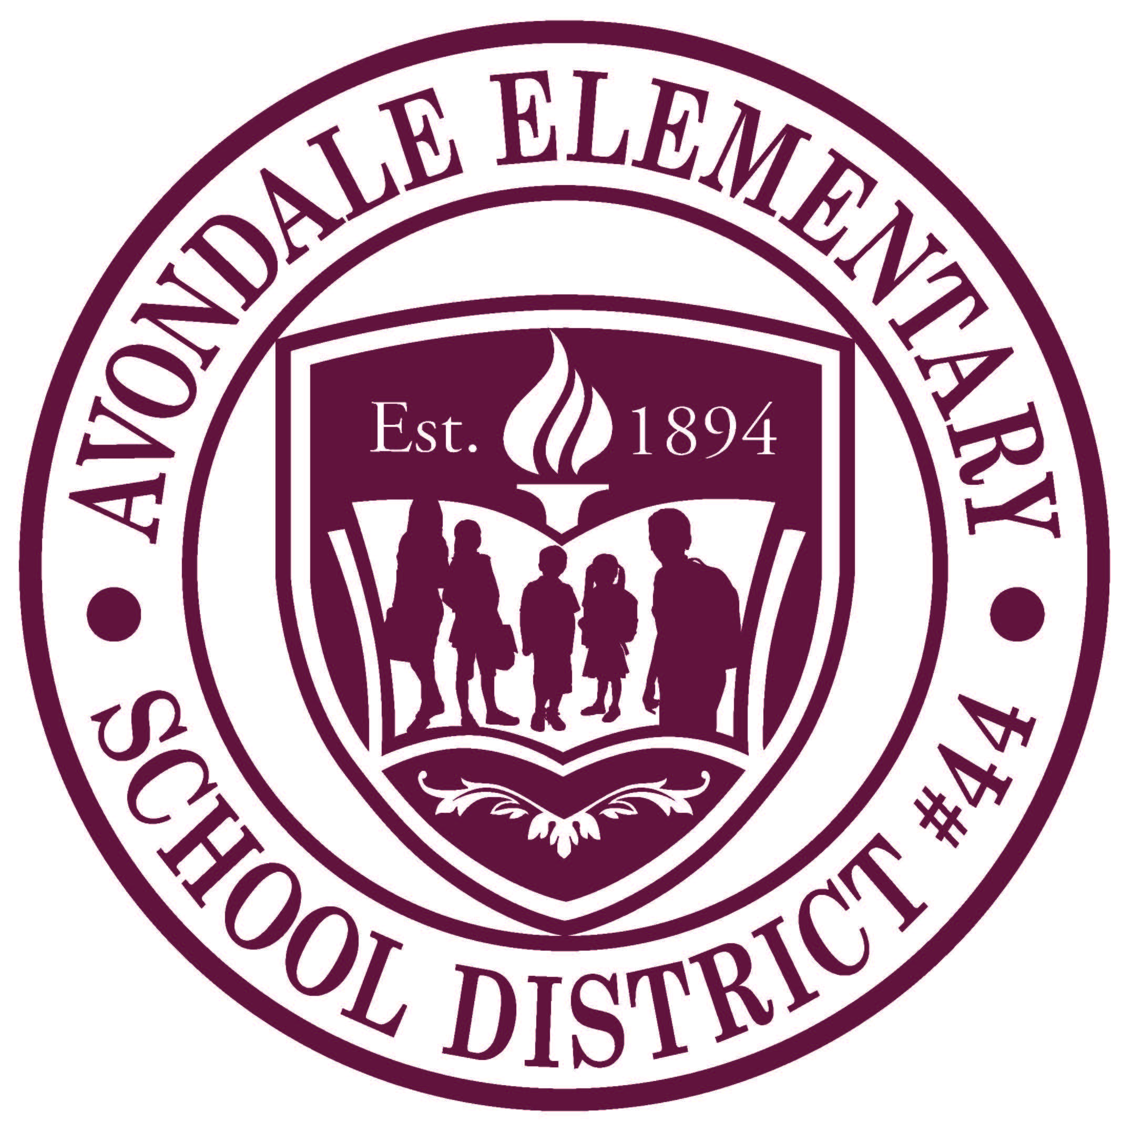

**“The function of education is to teach one to think intensively and to think critically, intelligence plus character – that is the goal of true education.”**

**~Martin Luther King**

|  |
| --- |
| **CONTENT without PURPOSE is only TRIVIA** |

**Prepared Especially for the**

**Collaborative Learning Team of**

**Avondale Elementary School District**

**by Dan Mulligan, flexiblecreativity.com**

**October 2017**

**Table of Contents**

|  |  |
| --- | --- |
| Unwrapping a Standard for Learning  *What do we want our students to know and do?* | 3 |
| Evidence of mastery  *How will we know when they know it?* | 4 |
| Framework for Instructional Planning  *What will we do to make sure they know and can do it?* | 6 |
| Creating an Environment for Learning  *How will we check for and build background knowledge?*  *How can we provide students with a context for their learning?* | 7 |
| Helping Students Develop Understanding  *What will we do to facilitate the transfer of understanding?* | 8 |
| Helping Students Extend and Apply Learning  *How will we facilitate each student’s ownership of essential concepts?* | 11 |
| Unpacking the minimum DOK level of learning | 14 |
| Collaboratively unpacking a standard | 16 |
| What Stuck with Me Today | 18 |

**Premise of Our Day**

|  |
| --- |
| Increasing students’ interest and involvement in the learning process while connecting with them on an emotional level is vital to learning success. By creating a nurturing, supportive environment, educators can help every student feel confident in their abilities and empowered to take ownership of their learning. |

**Understanding the Target for Each Student to Achieve**

***Ensuring each student is as a thinker, problem solver, and communicator***

**Step 1: Unwrap a Standard: *What do students have to know and be able to do?***

|  |  |
| --- | --- |
| **Copy/paste the standard and any performance Level Descriptor for Proficiency**   * **Underline the nouns.** * ***Circle or italicize the verbs.*** | |
| **Essential Knowledge/Concepts**  ***What Do Students Need to Know/Understand?***  **List the underlined nouns** | **Essential Skills**  ***What Do Students Need to Be Able to Do?***  **List the circled (or *italicized*) verbs** |
| **Depth of Knowledge**  **Highlight the DOK level of the standard (*see resource*)**   * **DOK 1 – Recall/Reproduction:** Recall a fact, information, or procedure. Process information on a low level. * **DOK 2 – Skill/Concept:** Use information or conceptual knowledge, two or more steps. * **DOK 3 – Strategic Thinking:** Requires reasoning, developing a plan or a sequence of steps, some complexity. * **DOK 4 – Extended Thinking:** Requires an investigation, time to think and process multiple conditions of the problem. Most on-demand assessments will NOT include level 4 activities. | **Essential Vocabulary**  ***What Do Students Need to Comprehend?***  **List all key vocabulary** |
| **Learning Objectives aligned to the Standard**  ***What ‘I can’ statement(s) will clarify the objective for students?*** | |
| **Evidence of Student Mastery?**  ***How will we know when they know it?*** | |
| **Specific Instructional Framework?**  ***What will we do to help them know/understand/can do it?***  ***What will we do for students who still don’t know it?***  ***What will we do for students who already know it?*** | |

**Evidence of Student Mastery**

***How will we know when they know it?***

|  |  |  |  |
| --- | --- | --- | --- |
| **Assessment Type** | **DOK/Bloom Alignment** | **Format** | **Usefulness and Resulting Evidence** |
| **Performance-Based Assessment** | **DOK 4**  **Extended Thinking**  **Bloom F**  **Create** | * Integrative tasks that yield specific products * Authentic assessments * Extended projects | Useful for assessing student:   * Ability to organize, synthesize, and apply information and skills * Use of relevant information |
| **Self-Assessment or Reflection** | **DOK 3**  **Strategic Thinking & Reasoning**  **Bloom E**  **Evaluate** | * Student journals or reflection logs * Student checklists (with comments) * Group (whole class or small group) reflection activities * Daily or weekly self-evaluations (Exit ticket) * Teacher-student conferences | * Develops student awareness of strengths and areas for improvement; conscious use of thinking skills (metacognitive skills) * Shows student process, thinking, & reasoning skills * Reveals student disposition toward topic or learning * Assists teacher and students identify personal learning goals |
| **Informal Assessment** | **DOK 2**  **Basic Skills & Concepts**  **DOK 3**  **Strategic Thinking & Reasoning** | * Teacher observations * Teacher checklists (rubrics) * Conversations or interviews | Depending on what is discussed or observed, these informal assessments may reveal student:   * Process or strategy used * Reasoning * Understanding of the topic * Ability to communicate and collaborate |
| **Open Tasks & Constructed Response** | **DOK 2**  **Basic Skills & Concepts**  **Bloom B, C**  **Understanding Applying** | * Tasks with different possible answers * Tasks with different possible processes * Technology Enhanced Items | Useful for assessing student ability to:   * Use processes; strategies * Interpret information * Apply information * Reasoning * Communicate thinking |
| **Closed Tasks** | **DOK 1**  **Recall & Reproduction**  **Bloom A/**  **Bloom C**  **Remembering**  **Understanding** | * Multiple-choice items * True-False Items * Fill-in-the-Blank items * Sole (without showing steps) * Technology Enhanced Items | * Useful for assessing content-based standards. Not useful for process-based standards * Assess student knowledge of facts, skills, or concepts * Take less time, thus allowing time for open-ended or performance-based assessments |

**Instructional Framework for Deep Understanding**

***What will we do to make sure they know and can do it?***

**Standard(s) including Essential Knowledge, Skills and Processes**

|  |
| --- |
|  |

**DOK Level of Standard(s)** (*this is a minimum target for student engagement we can*

*differentiate scaffolding later in the plan)*

|  |
| --- |
|  |

**Essential Vocabulary**

|  |  |
| --- | --- |
| Background Vocabulary – *these are words we will use to explain the new concepts –check for understanding* | New Vocabulary – *these are terms essential to understanding the new concepts* |

**Essential Question(s)** *(this is the driving question to frame the learning process)*

*What do we want students to know and be able to do?*

|  |
| --- |
|  |

**Assessment**:

*What evidence will we accept that they can do it?*

*What will students do to provide evidence of their level of proficiency in owning the essential understandings minimally at the stated DOK level?*

|  |
| --- |
|  |

**Framework for Learning**

*What are our strategies for accomplishing this?*

Pre-Assess/Create an Environment for Learning:

*How will we check for and build students’ background knowledge?*

*What will students do to connect new learning to prior knowledge?*

|  |
| --- |
|  |

Help Students Develop Understanding:

*What will we do to assist student’s as the acquire understanding?*

*What will students do to provide evidence of understanding? Differentiation?*

|  |
| --- |
|  |

Help Students Extend and Apply Knowledge:

*What will we do to facilitate students extending their thinking?*

*How will students summarize and apply knowledge?*

|  |
| --- |
|  |

How will we respond to those struggling and those excelling? *Differentiation?*

|  |
| --- |
|  |

**Excellence for All**

**Framework for Instructional Planning**

|  |  |
| --- | --- |
| **Essential Component** | **What it looks like** |
| **Clear Objective/Vocabulary** Unpacked/referenced by teacher/students throughout learning | What do we want our students to know and be able to do? |
| **Creating an Environment for Learning**  Provides students with context  Allows teacher to build/check for background knowledge | How will we check for readiness and provide a context for learning?  What will we do for students who already know it? |
| **Helping Students Develop Understanding**  This is the teaching/learning/discovering phase. Multiple checks for understanding along the way. Modeling, Guided Practice, Independent Practice | What will we do to help students understand the content? What will we do to help students develop skills? |
| **Helping Students Extend & Apply Knowledge**  Student reflection & doing something with what they learned. | How will we know when they know it?  What will we do for students who still don’t know it? |

**Essential Question:**

What will we do to make sure they know and can do it?

**Creating an Environment for Learning**

**Creating an Environment for Learning** resources assist with setting a purpose, checking for and building background knowledge to activate and engage student learning.

|  |
| --- |
| **Essential Question:**  How will we check for readiness and provide a context for learning |

|  |  |
| --- | --- |
|  |  |
| My strategies to ‘create an environment for learning’ | |

**Helping Students Develop Understanding**

**Helping Students Develop Understanding** facilitates each student's opportunity to increase understanding and supports checking of knowledge and skill acquisition along the way.

|  |
| --- |
| **Essential Question:**  What will we do to help students understand the content? What will we do to help students develop skills? |

|  |  |
| --- | --- |
|  |  |
| My strategies to ‘create an environment for learning’ | |

**Suggested Learning Strategy – Vocabulary**

**Guide students as they create a ‘personal glossary’ at the end of each unit in their electronic/paper interactive notebook.**

|  |  |
| --- | --- |
| **bargif** |  |

**Suggested Learning Strategy – Second Questions**

**Guide students to think deeper about essential knowledge by asking follow-up questions that require students to justify their thinking.**

|  |
| --- |
|  |

|  |
| --- |
| **What stuck with me about developing understanding:** |

Student-Teacher Roles in Developing Understanding

and Increasing Mathematical Reasoning

|  |  |
| --- | --- |
| **Instead of** | **Try…** |
| Calling on a few raised hands during a discussion | Asking all students to engage   * Ask everyone to write their response first * Use Think Pads (Think-Pair-Share) before whole class discussion |
| Having your voice dominate discussion time | Student led discussion   * Challenge yourself NOT to narrate the entire solution to a problem * “Tell your partner what Jose suggested we do next”; “Why do you think she is correct?”; “Can someone build on that?”; “Thoughts?”; “Do you agree?”; “Disagree?”; “Why?” |
| You do most of the problem solving | Getting students to read and re-read   * “Re-read the problem to yourself”; “What do we need to find out?”; “What did they tell us we can use?”; “What can we do to answer the question?”; “Is there another way we can solve this question?” |
| You summarizing the lesson | * Asking students to collaboratively summarize strategies used during the lesson. “What stuck with you today?” |

**Suggested Learning Strategy – Student-centered Tools**

|  |  |
| --- | --- |
|  |  |

**Helping Students Extend and Apply Knowledge**

**Helping Students Extend and Apply Knowledge** is more than summarizing ... it empowers each student to apply and create with their new understandings and skills.

|  |
| --- |
| **Essential Question:**  How will we know when they know it? |

|  |  |
| --- | --- |
|  |  |
|  | |

**Suggested Learning Strategy – Anchor Charts – Making Thinking Visible**

* build a culture of literacy in the classroom, as teachers and students make thinking visible by recording content, strategies, processes, cues, and guidelines during the learning process.
* keeps relevant and current learning accessible to students to remind them of prior learning and to enable them to make connections as new learning happens.
* Empowers students to refer to the charts and use them as tools as they answer questions, expand ideas, or contribute to discussions and problem-solving in class.

**Anchor Chart Samples:**

|  |  |
| --- | --- |
| Image result for anchor charts | Chemistry Anchor charts | Principles of Biomedical Sciences - Todd County High School |
| **Picture of Chart can be placed in student notebooks…** | |

**Suggested Learning Strategy – Student-centered Tools**

|  |  |
| --- | --- |
|  |  |
|  |  |
|  |  |

**Knowing and Formatively Assessing the Target**

**How do students need to express their understanding?**

**Unpacking the Essential Skills of Standards Planning Assessment for Learning**

|  |  |  |  |
| --- | --- | --- | --- |
| **Level of Complexity** | **Key Verbs that may Clue Level** | | **Evidence of DOK** |
| **Level 1**  **Recall/Reproduction**  Recall a fact, information, or procedure. Process information on a low level.  **Bloom**  *Know/Remember*  The recall of specifics and universals, involving little more than bringing to mind the appropriate material.  *Comprehend/Understand*  Ability to process knowledge on a low level such that the knowledge can be reproduced or communicated without a verbatim repetition. | Arrange  Calculate  Cite  Define  Describe  Draw  Explain  Give examples  Identify  Illustrate  Label  Locate  List  Match | Measure  Name  Perform  Quote  Recall  Recite  Record  Repeat  Report  Select  State  Summarize  Tabulate | * Explain simple concepts or routine procedures * Recall elements and details * Recall a fact, item or property * Conduct basic calculations * Order rational numbers * Identify a scientific representation for simple phenomena * Label locations * Describe the features of a place or people * Identify figurative language in a reading passage |
| **Level 2**  **Skill/Concept**  Use information or conceptual knowledge, two or more steps  **Bloom**  *Apply*  Uses information in another familiar situation.  Executes – carries out a procedure in a familiar task  Implements – uses a procedure in an unfamiliar task | Apply  Calculate  Categorize  Classify  Compare  Compute  Construct  Convert  Describe  Determine  Distinguish  Estimate  Explain  Extend  Extrapolate  Find  Formulate | Generalize  Graph  Identify patterns  Infer  Interpolate  Interpret  Modify  Observe  Organize  Predict  Relate  Represent  Show  Simplify  Solve  Sort  Use | * Solve routine multiple-step problems * Describe non-trivial patterns * Interpret information from a simple graph * Sort objects * Show relationships * Apply a concept * Organize, represent and interpret data * Use context clues to identify the meaning of unfamiliar words * Describe the cause/effect of a particular event * Predict a logical outcome * Identify patterns in events or behavior |

**Unpacking the Essential Skills of Standards Planning Assessment for Learning**

|  |  |  |  |
| --- | --- | --- | --- |
| **Level of Complexity** | **Key Verbs that may Clue Level** | | **Evidence of DOK** |
| **Level 3**  **Strategic Thinking**  Requires reasoning, developing a plan or a sequence of steps, some complexity  **Bloom**  *Analyze*  Breaking information into parts to explore understanding and relationships.  *Evaluate*  Checks/Critiques – makes judgements based on criteria and standards | Appraise  Assess  Cite evidence  Check  Compare  Compile  Conclude  Contrast  Critique  Decide  Defend  Describe  Develop  Differentiate  Distinguish | Examine  Explain how  Formulate  Hypothesize  Identify  Infer  Interpret  Investigate  Judge  Justify  Reorganize  Solve  Support | * Solve non-routine problems * Interpret information from a complex graph * Explain phenomena in terms of concepts * Support ideas with details and examples * Develop a scientific model for a complex situation * Formulate conclusions from experimental data * Compile information from multiple sources to address a specific topic * Develop a logical argument * Identify and then justify a solution * Identify the author’s purpose and explain how * Identify the author’s purpose and explain how it effects the interpretation of a reading selection |
| **Level 4**  **Extended Thinking**  Requires an investigation, time to think and process multiple conditions of the problem. Most on-demand assessments will not include Level 4 activities  **Bloom**  *Synthesize*  Putting together elements and parts to form a whole  *Evaluation*  Making value judgements about the method | Appraise  Connect  Create  Critique  Design  Judge  Justify  Prove  Report  Synthesize |  | * Design and conduct an experiment that requires specifying a problem, report results/solutions * Synthesize ideas into new concepts * Critique experimental designs * Design a mathematical model to inform and solve a practical or abstract situation * Connect common themes across texts from different cultures * Synthesize information from multiple sources |

**Understanding the Target for Each Student to Achieve**

***Ensuring each student is as a thinker, problem solver, and communicator***

**Step 1: Unwrap a Standard: *What do students have to know and be able to do?***

|  |  |
| --- | --- |
| **Copy/paste the standard and any performance Level Descriptor for Proficiency**   * **Underline the nouns.** * ***Circle or italicize the verbs.***   **5.NF.B.7**  Apply and extend previous understandings of division to divide unit fractions by whole numbers and whole numbers by unit fractions.   a. Interpret division of a unit fraction by a non-zero whole number, and compute such quotients. Use the relationship between multiplication and division to justify conclusions.  b. Interpret division of a whole number by a unit fraction, and compute such quotients. *For example, create a story context for 4 ÷ (1/5), and use a visual fraction model to show the quotient.* Use the relationship between multiplication and division to justify conclusions (e.g., 4 ÷ (1/5) = 20 because 20 x (1/5) = 4).  c. Solve problems in real-world context involving division of unit fractions by non-zero whole numbers and division of whole numbers by unit fractions, using a variety of representations. | |
| **Essential Knowledge/Concepts**  ***What Do Students Need to Know/Understand?***  **List the underlined nouns** | **Essential Skills**  ***What Do Students Need to Be Able to Do?***  **List the circled (or *italicized*) verbs** |
| **Depth of Knowledge**  **Highlight the DOK level of the standard (*see resource*)**   * **DOK 1 – Recall/Reproduction:** Recall a fact, information, or procedure. Process information on a low level. * **DOK 2 – Skill/Concept:** Use information or conceptual knowledge, two or more steps. * **DOK 3 – Strategic Thinking:** Requires reasoning, developing a plan or a sequence of steps, some complexity. * **DOK 4 – Extended Thinking:** Requires an investigation, time to think and process multiple conditions of the problem. Most on-demand assessments will NOT include level 4 activities. | **Essential Vocabulary**  ***What Do Students Need to Comprehend?***  **List all key vocabulary** |
| **Learning Objectives aligned to the Standard**  ***What ‘I can’ statement(s) will clarify the objective for students?*** | |
| **Evidence of Student Mastery?**  ***How will we know when they know it?*** | |
| **Specific Instructional Framework?**  ***What will we do to help them know/understand/can do it?***  ***What will we do for students who still don’t know it?***  ***What will we do for students who already know it?*** | |

**What Stuck with Me Today**