Increasing Student Engagement with Global Connections | 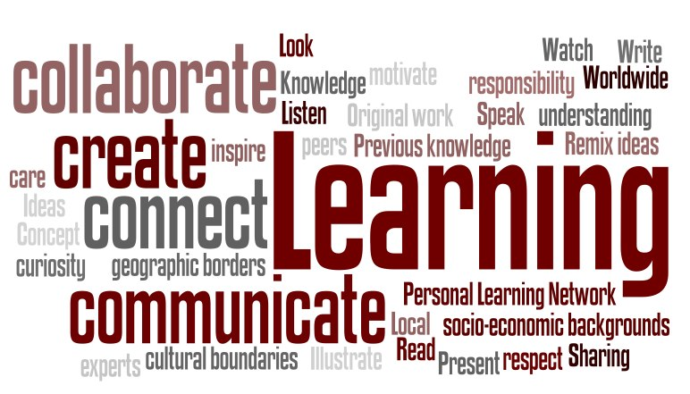

Resource | Description/Justification | Why use it?
Wheel Decide  http://wheeldecide.com | Speed dating: It sounds risqué but only entails lining up desks in rows facing each other. Teacher or student creates discussion topics (record on Think Pad) which change topics every two to five minutes. The students in one row remain in their seats, and the ones facing them move every time the time expires. Every few minutes, new pairs have a conversation that are recorded while the teacher checks for understanding.
Quadblogging  http://quadblogging.net | Creates an audience for student blogs by grouping four classrooms. Each week, a different class is the focus class and the three other classes visit and comment on the focus class blog.
Digital Readworks  http://readworks.org and http://digital.readworks.org | Provides one of the largest K-12 collections of award-winning, authentic, nonfiction, and literary articles. The digital version allows creation of class lists to assign formative assessments. Students can read the articles online that will be partially graded by ‘readworks’.
100 Word Challenge  http://100wc.net | Provides a creative writing challenge for students under 16. Students write a creative piece of up to 100 words in response to a prompt posted each week. Students comment on one another’s pieces, and individual pieces are recognized each week.
Poster Makers/Presenters  https://www.easel.ly/ | Have students working in pairs use a website such as Canva or Easel.ly to create posters answering the question. Next, have them present their posters to the class.
ePals  www.epals.com | ePals offers pairing services for schools from around the world that are eager to learn from one another. Classrooms can access over 200 countries via live video chat, creating a unique learning community where young people experience a little bit of life in a foreign country while forming dialogues and lasting friendships. ePals represents the world's largest network of K-12 classrooms, and best of all, it’s free.
Global Math Twitter Challenge  http://gmttc.blogspot.com | Participating classes use Twitter to share math challenges and answer challenges that others have shared. Classes can join at any time by following the hashtag for their grade level.
Global Monster Project  www.smithclass.org/proj/Monsters/index.htm | Students describe a ‘monster’ so that others in the world can then create it and share via video and blog posts.
Skype in the Classroom  https://education.microsoft.com/skype-in-the-classroom | Many activities are offered through the Microsoft site, including the popular “Mystery Skype,” in which two classrooms Skype and students ask questions to determine where their partners are located in the world. Rich conversations usually take place, leading to further activities around the real-time linkup.
iEARN Learning Circles  http://iearn.org/circles | The iEARN organization connects classrooms for intercultural understanding and interaction that leads to collaboration. Learning circles consist of six-eight classrooms that determine a theme and collaborate on authentic student work, such as ebooks and websites.
My Contribution:

Pail of prompts: Make slips of papers with different scenarios related to your unit. Have students draw them out of a pail and practice a conversation on the topic. Next, have each group go to the front of the room and talk about their topic for one or two minutes. Set a timer and have them talk until the time runs out.
Silent exchanges: Give students working in pairs a topic related to the current unit. Have each pair create a Google document that they share with each other and with you. Each pair has a written conversation on the topic. The teacher can monitor the conversations and give feedback via the Google doc. This allows students valuable interpersonal writing practice before they move on to the more high-pressure exercise of interpersonal speaking. Once they have practiced the conversation in silence, have them read it out loud.
First Five Fridays: Assign each student (or pair of students) in your class a Friday or two during the school year when he or she has to direct a conversation for the first five minutes of class. During this time, he or she can broach any (appropriate) topic. Students are responsible for making sure the conversation stays alive for the entire five minutes.

