Grade 3 ELA
Unwrap a Standard: What do students have to know and be able to do?

Domain: Reading Standards for Informational Text
Where can this be found? Why do we care?
Domain Weight: 26% - 35% of AASA assessment items
Standard: 3.RI.2 Determine the main idea of a text; recount and paraphrase the key details and explain how they support the main idea.
Emerging (1) | Developing (2) | Proficient (3) | Distinguished (4)
I can identify an explicitly stated main idea of a text.  I can identify key details to recount.  I can paraphrase the main idea. | I can determine the main idea of a text.  I can identify key details to recount and paraphrase the main idea.  Where can these be found? How can we use these? Why? | I can determine the main idea of a text.  I can recount and paraphrase key details and explain how they support the main idea. | I can determine an implicitly stated main idea of a text.  I can recount and paraphrase key details and explain how they support the main idea.
Flashback Standard: 2.RI.2 Identify and explain the main topic of a multi-paragraph text as well as the focus of the specific paragraphs within the text.
Preview Standard: 4.RI.2 Determine the main idea of a text and explain how it is supported by key details; summarize the text.
Why bother?
Arizona Performance Level Descriptors 3.RI.2 (HT, MC, MS, EbSR, GM/GMT)

AZ resources for unpacking: 3.RI.2

AASA Item Specifications:
Stimuli Type | Reading Passage
Content Limits | Content Standard item may ask the student to use details from a text to determine a main idea. These may be explicitly or implicitly stated. Items may ask the student to identify key details and explain how they convey the main idea.

Task Demand | Common Item Formats
Determine a main idea explicitly or implicitly stated in the text.  Where can these be found? Why do we care? | - Multiple Select (MS)  - Multiple Choice (MC)  - Evidence-based Selected Response (EbSR)  - Gap Match/ Gap Match Table (GM/GMT)  - Hot Text (HT)
Determine a main idea and provide one or more key details that support the theme or central idea of the text.
Determine the main idea and explain how it is supported using a single detail.
Determine the main idea and explain how it is supported using multiple details.

Sample AASA Items
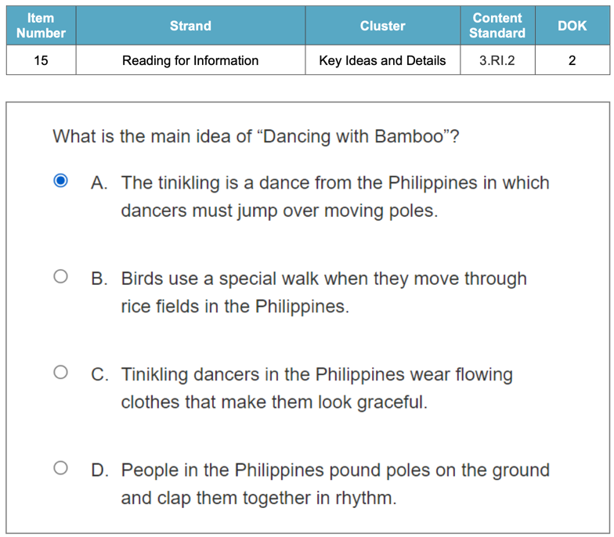
Where can this be found? How can we use these?

Essential Knowledge/Concepts  What Do Students Need to Know/Understand?  List the underlined nouns  Main Idea Key Details Text Detail  Implicit Explicit Supporting Details  FBS: Main Topic | Essential Skills  What Do Students Need to Be Able to Do?  List the circled (or italicized) verbs  Identify Paraphrase Recount Determine  Explain  FBS: Identify Explain
DOK Level
Level of content complexity rather than content difficulty.

DOK 1 DOK 2 DOK 3
Essential Questions/Tasks  Why bother? How can we use these?  How can we capture student wonder?  *Including open-ended and ‘second’ questions  Why do you think the author included certain details in the story? How do they help convey the main idea?  What clues or hints in the text helped you figure out the main idea?  Compare and contrast two key details from the text. How are they similar, and how are they different?  Create two questions that are answered in the text. | Essential Vocabulary  What Do Students Need to Comprehend?  List all key vocabulary  Main Idea Central Theme Key Details  Supporting Evidence Summary  Recount Paraphrase Inference  Context Clues Key Details. Supporting details
Learning Objectives aligned to the Standard
What are the Learning Intentions and Success Criteria that will guide student progress?

See attached visible learning chart (LISCAZ3.RI.2
Evidence of Student Mastery?
How will we know when they know it?

See attached Diagnostic Quick Check (DFA AZ3.RI.2)
Specific Instructional Framework?
What will we do to help them know/understand/can do it?
What will we do for students who still don’t know it?
What will we do for students who already know it?

See attached Thinking Routines and Small Group Strategies (DFA AZ3.RI.2)

Evidence of Student Mastery?
How will we know when they know it?

Passage 1: Noche de los Rabanos
This text is provided curtesy of Vanderbilt University: Center of Latin American Studies

In the town of Oaxaca in Southern Mexico, there is a holiday called Noche de los Rábanos(Night of the Radishes). When the Spanish conquerors came to Mexico in the 1500s, they brought the radish with them and introduced it to the Mexicans. While radishes were typically eaten as a side dish or a snack, Mexican vendors began to carve large and oddly shaped radishes into religious figures to sell at the annual Christmas market on December 23. Religious priests encouraged the radish carvings, and people began to buy radishes as Christmas decorations.

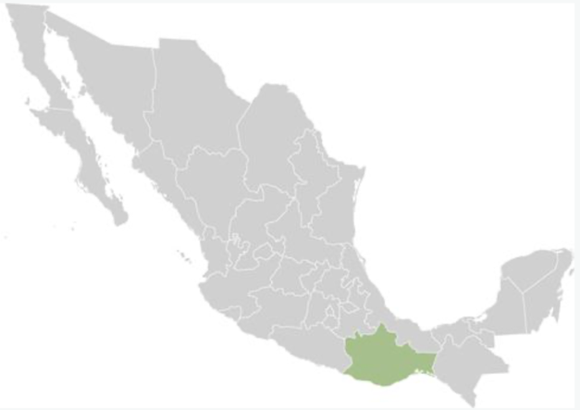 | 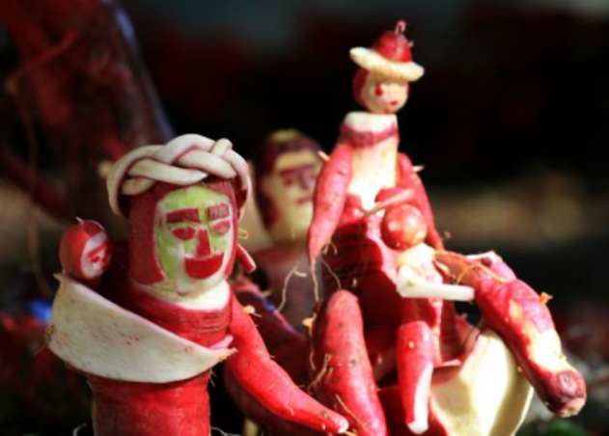

As the radish carvings became more popular each year, more vendors began to make them. In 1897, the mayor of Oaxaca created an official radish carving competition. This competition continued to be held every year and became known as Noche de los Rábanos. Today, the competition has over 100 entries and thousands of visitors. Radishes are still carved into religious scenes, as well as into images from Day of the Dead, traditional dances, scenes from Oaxaca’s history, famous people, local animals and food, and monsters.
The city government has dedicated farmland in town to grow the radishes used for the competition. Farmers leave the radishes in the ground for as long as possible to make them large enough for carving. The radishes can be over 1.5 feet long and weigh over two pounds! Government officials harvest the radishes on December 18 to distribute to contestants, giving them five days to design their carving. Participants carve the radishes on December 23. Today, there is also part of the competition for sculptures made from corn husks and dried flowers.
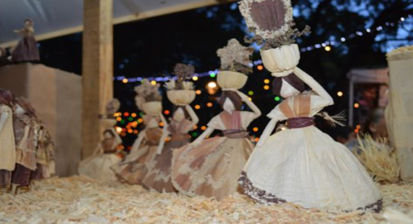
Item #1: Alignment to ALD 3.RI.2.0 (Flashback to 2.RI.2)

What does Noche de los Rabanos mean in English?
- Night of the Radishes
- Night of Religions
- Night of Side Dishes
Why start with the easiest question and increase performance level of each question? How can we use the results?
- Night of the Decorations

Item #2: Alignment to ALD 3.RI.2.1

What caused people in Oaxaca to start buying radishes as Christmas decorations?
Circle the box that contains the best answer to the question

Spanish conquerors believed radishes were an important religious food. |  | Religious priests told people that radishes were a healthy side dish. |  | People competed to see how many Christmas decorations they could have in their house. |  | Mexican vendors started carving religious figures into radishes and selling them.
Why simulate a Hot Spot item with this standard?

Item #3: Alignment to ALD 3.RI.2.2

Read the following sentences.
“Mexican vendors began to carve large and oddly shaped radishes into religious figures...Radishes are still carved into religious scenes, as well as into images from Day of the Dead, traditional dances, scenes from Oaxaca’s history, famous people, local animals and food, and monsters.”
What can you conclude based on this information?
- People in Oaxaca no longer celebrate the radish carving competition.
- Radish carvings in Oaxaca have changed over the years.
- Many famous people attend the radish carvings competition.
- Radish carvings in Oaxaca have not changed since the first festival.

Item #4: Alignment to ALD 3.RI.2.3

What is the main idea of the text?

- Noche de los Rábanos is a radish carving competition with over 100 entries and thousands of visitors.
- Noche de los Rábanos is a radish carving competition that celebrates religion, culture, and history in Oaxaca, Mexico.
- Noche de los Rábanos is a radish growing competition where farmers grow radishes large enough for carving.
- Noche de los Rábanos is a sculpture carving competition where people buy sculptures made from corn husks and dried flowers.

Item #5: Alignment to ALD 3.RI.2.3

What is one example of how the Oaxaca city government helps support the radish carving competition? Why is this important to the people of the city?

Item #6: Alignment to ALD 3.RI.2.4

What is one thing that Noche de los Rábanos tells us about Oaxacan history?
Support your answer with evidence from the text.

Step 4: Create a My Personal Goals Chart for each student to note their progress with each success criteria.

Success Criteria | Getting Started | On My Way | I’m There | Notes to Self
I can identify an explicitly stated main idea of a text.
I can identify key details to recount. |  |  | Why should students chart their progress?
I can paraphrase the main idea.
I can determine the main idea of a text.
I can identify key details to recount and paraphrase the main idea.
I can recount and paraphrase key details and explain how they support the main idea.
I can determine an implicitly stated main idea of text.
I can recount and paraphrase key details and explain how they support the main idea.

Step 5:
Collaboratively determine small group experiences to move each student toward proficiency and beyond.

Guided Group Lesson Date:

Standard:

Group Members | Emerging | Developing | Proficient | Distinguished
 |  |  | Why individualize each student’s progress compared to standards?

Warm-Up:
With your partner, play a game of ‘Where Do I Belong’. Match Each main idea with one or more supporting details that support the main idea. Prepare to explain your selections.

Vocabulary

Main Idea Central Theme Key Details

Supporting Evidence Summary Recount Paraphrase Inference

Context Clues Key Details Supporting details

Emerging | Developing | Proficient | Distinguished
Lesson focus:  Where can these be found?  You and your partner have been hired at chefs in La-te-da Restaurant. Use the ‘Zoom In’ slide to determine the main idea of the attached recipe and the supporting details to make a delicious meal. | Lesson focus:  You are a movie critic for the local TV station. Watch the movie clip provided by your teacher. Complete the ‘These are, These are Not’ chart and then summarize the movie and paraphrase key details to explain how they support the main idea of the movie. | Lesson focus:  Read the news article, provided by your teacher, on a current event. Use your expertise as a reporter to determine the main idea. Use facts, quotes, and examples in the article as supporting details.  Why plan for data-driven small group instruction? | Lesson focus:  You have been hired by a publishing firm to write a factual article on your favorite animal. After writing the article, identify the main idea and supporting details you used to create the article.

Observations:  Aren’t we done after providing one small group experience? |  | Next Steps:
What you notice about your students during small group instruction. |  | What will you do with these students next? Change groups, repeat, etc.
Charting My Progress Reaching My Personal Goals ELA 3 Individual Component Version

Learning Intention: I am learning to determine the main idea of a text; recount and paraphrase the key details and explain how they support the main idea.
My Success Criteria | ? | Why am I learning This?
I can determine the main idea of a text. | I’m There  On My Way  Getting Started | Why bother?
I can recount the main events or key points in a text. | I’m There  On My Way  Getting Started
I can paraphrase the key details using my own words. | I’m There  On My Way  Getting Started
I can explain how the key details support the main idea. | I’m There  On My Way  Getting Started
Vocabulary:
Main Idea Supporting Details Paraphrase Key Details

Implicit Explicit Summarize

ELP: | Standard:  AZ 3.RI.2 Determine the main idea of a text; recount and paraphrase the key details and explain how they support the main idea.
What stuck with me? Why is it important to remember?
(include any combination of images, numbers, and words)

Where am I with determining the main idea and key details?
Criteria | Distinguished | Proficient |  | Developing | Emerging
Main Idea | I accurately determine the main idea of the text and provide a clear and concise explanation of how the key details support it. | I determine the main idea of the text and provide an explanation of how the key details support it, although some clarity or conciseness may be lacking. |  | I determine the main idea of the text, but my explanation of how the key details support it is incomplete or unclear. | I inaccurately determine the main idea of the text or do not explain how the key details support it.
Recounting | I effectively recount the key details of the text in a sequential and organized manner. | I recount the key details of the text in a mostly sequential and organized manner but may contain minor inaccuracies or omissions.  Why bother? |  | I recount some of the key details of the text but lack organization or coherence. | I do not effectively recount the key details of the text.
Paraphrasing | I skillfully paraphrase the key details of the text using different words or phrases that accurately convey the meaning. | I paraphrases the key details of te text using different words or phrases, but I may occasionally rely on direct copying or miss some important elements. |  | I attempt to paraphrase the key details of the text, but often I resort to direct copying or do not fully capture the meaning. | I do not effectively paraphrase the key details of the text.
Supporting the Main Idea | I provide a thorough explanation of how the key details support the main idea, using specific examples and evidence from the text. | I provide an explanation of how the key details support the main idea but may lack some specificity in examples or evidence. |  | I attempt to explain how the key details support the main idea but lack clarity or do not provide sufficient examples/evidence. | I do not effectively explain how the key details support the main idea.
What are things I know? Explain. |  |  | What are my opportunities? Explain.

Small Group Choice Board Samples

Options | Description
Summarize and Draw | Read a text and write a summary, then create a visual representation of the main idea.
Main Idea Match-Up | Match key details to their corresponding main ideas in a text using a graphic organizer.
Main Idea Detective | Read a short passage and identify the main idea by underlining it and writing a sentence about it.
Main Idea Web | Create a web graphic organizer to identify the main idea and supporting details in a text.
Picture Perfect | Choose a picture book and write a paragraph explaining the main idea of the story.
Important Details | Select a text and identify three important details that support the main idea.
Main Idea Sort | Sort given sentences into categories based on their corresponding main ideas
Main Idea Timeline | Create a timeline of events from a nonfiction text and write a main idea statement about the text.
Main Idea Opinion | Write a paragraph expressing your opinion about the main idea of a text and support it with evidence from the text.  Why bother?
Small Group Activities:
Main Idea Collage | - Give each group a magazine or a set of printed articles.  - Ask them to find articles or pictures that represent the main idea of a given topic.  - Have students cut out the images and arrange them on a poster board.  - In a short presentation, they should explain how each picture or article supports the main idea.
Story Sequencing | - Provide each group with a short story or passage.  - Ask students to work together to identify the main idea of the story.  - Have them create a sequence of key events that support the main idea.  - Encourage them to use their own words to recount and paraphrase each event.
Text Mapping | - Provide each group with a short informational text.  - Have students create a visual map that includes the main idea at the center and key details branching out.  - Encourage them to use words and drawings to represent each detail and explain how it relates to the main idea.
Reader’s Theatre | - Choose a short play or script that conveys a clear main idea.  - Assign roles to each group member and have them perform the play.  - After the performance, discuss how each character and scene contribute to the main idea.
Sentence Sort | - Prepare a set of sentences related to a specific topic.  - Ask students to work together to sort the sentences into two groups: those that contribute to the main idea and those that do not.  - Encourage them to explain their choices and justify why certain sentences support the main idea
Picture Book Analysis | - Provide each group with a picture book.  - Ask them to identify the main idea of the book and select key details from the illustrations and text.  - Have students present their findings to the class, explaining how the pictures and words work together to convey the main idea.
\
What part of this process has value to you and your students?

