Math 4
Diagnostic Formative Assessment

Unwrap a Standard: What do students have to know and be able to do?

Domain: Measurement & Data and Geometry
Domain Weight: 7% - 11% of items, 18.5% of standards

Solve problems involving measurement and conversion of measurements from a larger unit to a smaller unit.
Standard: 4.MD.A.3 Apply the area and perimeter formulas for rectangles in mathematical problems and problems in real-world contexts including problems with unknown side lengths.
Emerging (1) | Developing (2) | Proficient (3) | Distinguished (4)
I can identify the area and perimeter for rectangles in mathematical problems. | I can identify the area and perimeter for rectangles in mathematical problems and problems in real-world contexts. | I can apply the area and perimeter formulas for rectangles in mathematical problems and problems in real-world contexts including problems with unknown side lengths. | I can explain the difference between the area and perimeter formulas for rectangles. Use the area and perimeter formulas to determine unknown side lengths of a rectangle.  I can create real-world applications of area and perimeter. *
Building Background Knowledge and skills: Flashback Standard

3.MD.C.6 Measure areas by counting unit squares (e.g., square cm, square m, square in, square ft, and improvised units.
Extending Knowledge and skills: Preview Standard

5.MD.C.4 Measure volumes by counting unit cubes, using cubic cm, cubic in, cubic ft, and improvised units.
Arizona Performance Level Descriptors MD.A.3 (EQR, GRR, MSR)
*Rigor increased by author from state PLD (high expectations).

Essential Knowledge/Concepts  What Do Students Need to Know/Understand?  List the underlined nouns.  Area Perimeter Rectangle  Area Formula Perimeter Formula  Unknown side length Square Unit  Unit (centimeter, meter, inch, foot)  FBS Area Unit Squares  PRS. Volume Unit Cubes | Essential Skills  What Do Students Need to Be Able to Do?  List the circled (or italicized) verbs.  Identify Apply Explain  Use Create Determine  FBS Measure Count  PRS Measure Count
DOK Level
Level of content complexity rather than content difficulty.

DOK 1 DOK 2 DOK 3 DOK 4*

Essential Questions  How can we capture student wonder?  *Including open-ended and ‘second’ questions  How would you describe the perimeter of a computer screen?  What is the same and what is different about the area and perimeter of a rectangle?  How can you decide whether a question involves the perimeter or area of a rectangle?  Create a situation that would involve finding the area of a rectangle. | Essential Vocabulary  What Do Students Need to Comprehend?  List all key vocabulary  Side Length Area Unit Square  Perimeter Unit Side  Formula Two-dimensional  Three-Dimensional  FBS  PRS Volume Unit Cubes
Learning Objectives aligned to the Standard
What ‘I can’ statement(s) will clarify the objective for students?

Evidence of Student Mastery?
How will we know when they know it?

Specific Instructional Framework?
What will we do to help them know/understand/can do it?
What will we do for students who still don’t know it?
What will we do for students who already know it?

My Learning Intention and Success Criteria 4.MD.A.3 Individual Component Version

My Learning Intention: I am learning to apply the area and perimeter formulas for rectangles in mathematical problems and problems in real-world contexts including problems with unknown side lengths.
My Success Criteria | Post | Why am I learning this?
I can demonstrate my understanding of the concepts of area and perimeter. | 🥳  🙂  🤔
I can accurately calculate the area and perimeter of rectangles using the appropriate formula. | 🥳  🙂  🤔
I can apply the formulas correctly in mathematical problems involving rectangles. | 🥳  🙂  🤔
I can apply the formulas in real-world contexts, such as calculating the area of a room for carpeting or determining the perimeter of a garden. | 🥳  🙂  🤔
I can solve problems with unknown side lengths by setting up and solving equations based on the given information. | 🥳  🙂  🤔
I can show consistency in using the formulas accurately in creating and solving various problem-solving scenarios related to rectangles. | 🥳  🙂  🤔
What do I want to remember?

Alignment to 4.MD.A.3.0 (Flashback to 3.MD.C.6) (DOK 1)

- Count the boxes to find the area of rectangle A.

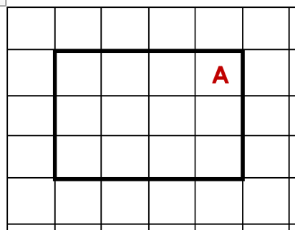

Area of rectangle A = _______

Alignment to MD.A.3.1 (DOK 1)

- PART A. Find the total distance around the rectangle.
PART B. Is this an example of area or perimeter?

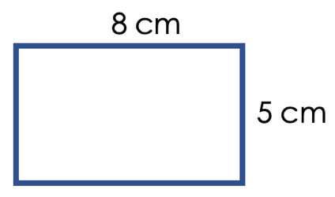

Alignment to MD.A.3.2 (DOK 2)

- Hilda is creating a frame to place around a rectangular painting. The painting is 12 cm long and 8 cm high.


Circle the equation Hilda can use to design her frame?

A = 12 x 8 |  | P = 12 + 8 |  | A = 12 x 8 + 12 x 8 |  | P = 2 x 12 + 2 x 8

Alignment to MD.A.3.2 (DOK 2)

- Maria is creating a rectangular garden for her mother. Her garden will be eight meters long and nine meters wide.

PART A. Draw and label a sketch of the garden.
PART B. Maria needs help finding the amount of space inside her garden. Find the area of the garden.

Alignment to MD.A.3.3 (DOK 2)

- Find the length of the missing side in the given rectangle if the perimeter is 28 ft.

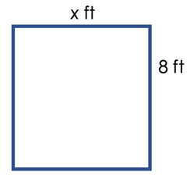
- 3.5 ft.
- 6 ft.
- 20 ft.
- 72 ft.

Alignment to MD.A.3.3 (DOK 3)

- PART A. Draw a rectangle on the grid below with an area of 48 sq cm.
PART B. State the length and width of the rectangle.

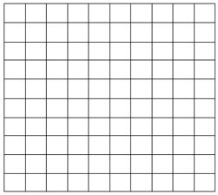

Alignment to MD.A.3.4 (DOK 3)

- Think of a time when knowing how to find the area or perimeter of a rectangle would have solved a question.
PART A. Describe the problem. Include approximate measures in your story to make it realistic.
PART B. Make a labeled sketch to illustrate your situation.
PART C. Solve your story.
Guided Group Lesson Date:

Standard: 4. MD.A.3 Apply the area and perimeter formulas for rectangles in mathematical problems and problems in real-world contexts including problems with unknown side lengths.
Group Members | Emerging | Developing | Proficient | Distinguished

Warm-Up:
Side Length Area Unit Square

Perimeter Unit Side

Formula Two-dimensional

Three-Dimensional

Vocabulary

Emerging | Developing | Proficient | Distinguished
Lesson focus:  Cindy plans on painting a 12^{I} by 8^{I} rectangular accent wall in her home. She requests your help in determining whether she should use the area or perimeter formular to determine how much space she needs to paint. Use sentences and images to explain what you recommend. | Lesson focus:  Carlotta’s class is creating a rectangular garden on the school property. The vegetable plants they want in the garden require 36^{I} square feet of space. Carlotta purchased 12^{I} of fencing to enclose the garden. Does she have enough fencing to enclose the garden? Explain your thinking with pictures, equations, and sentences. | Lesson focus:  Carlos noticed perimeter of a rectangle is expressed in units. He also realized area of a rectangle is expressed in square units. Explain why the difference in expressing perimeter and area is important to apply to our solutions to mathematical problems. | Lesson focus:  Penny has been asked by her teacher to create two questions for the next quiz. She is tasked with creating a real-world area of a rectangle situation and a real-world perimeter of a rectangle situation. Inclue practical numbers to fit each real world situation.

Observations: |  | Next Steps:
What you notice about your students during small group instruction. |  | What will you do with these students next? Change groups, repeat, etc.

