Elements of Effective Learning
What instructional strategies will produce the best results for each learner?

Clear Objective (Essential Question) /Vocabulary  Referenced by teacher/students throughout learning | Constantly checking for the understanding of each student.  Constantly responding to checks for understanding  (differentiation)  Seize opportunities for student collaboration on second questions!  Purposeful Spiraling (learning is not linear)
Activating Student Background Knowledge
Provides students with context
Allows teacher to build/check for background knowledge

Creating an Environment for Learning
Develop Student Understanding
This is the teaching/learning/discovering phase. Multiple checks for understanding along the way. Facilitating discovery, modeling, Guided Practice, Independent Practice

Helping Students Develop Understanding
Facilitate Student-Centered Closure
Student reflection & doing something with what they learned.

Helping Students Extend and Apply Knowledge

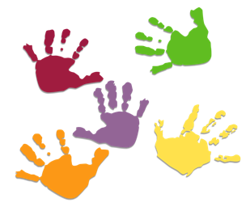
‘The difference between who you are and who you want to be is what you do.’
~Bill Phillips

Clear Objective (Essential Question) /Vocabulary
Referenced by teacher/students throughout learning
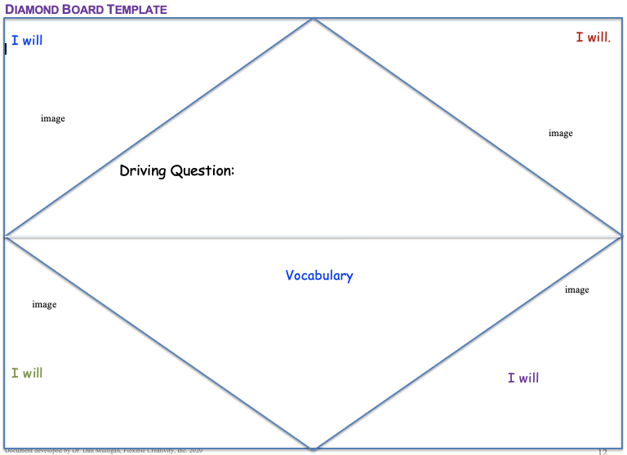 | 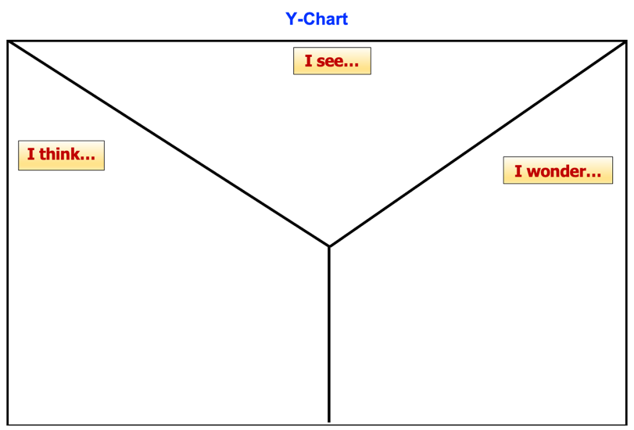
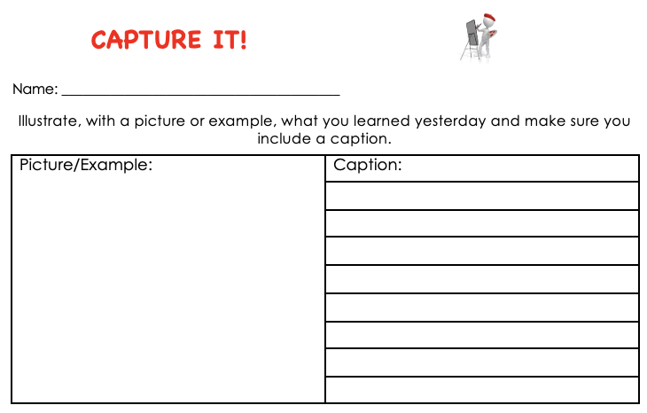 | 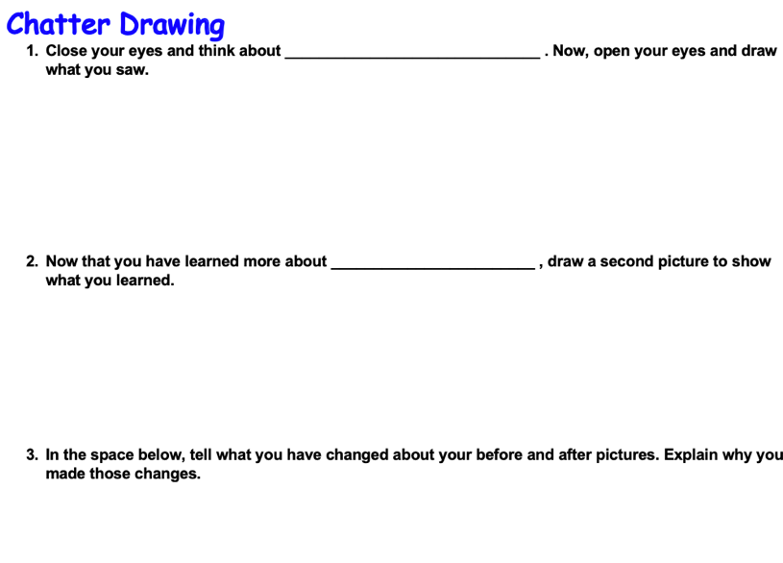
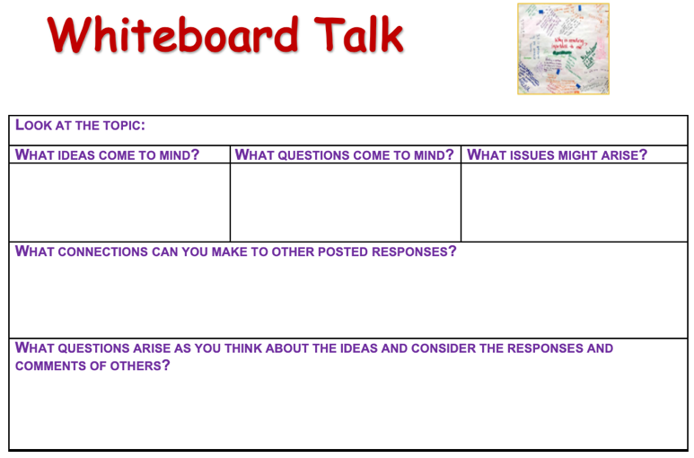 | 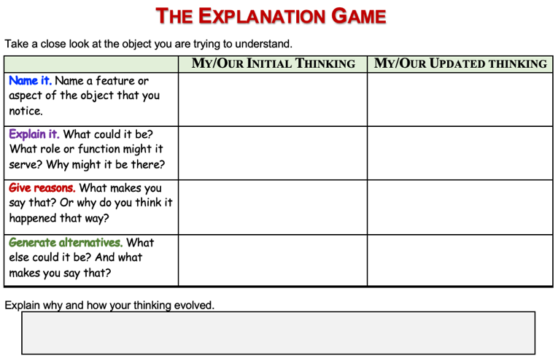

*Constantly responding to checks for understanding (differentiation)*
Activating Student Background Knowledge
Provides students with context. Allows teacher to build/check for background knowledge

Creating an Environment for Learning
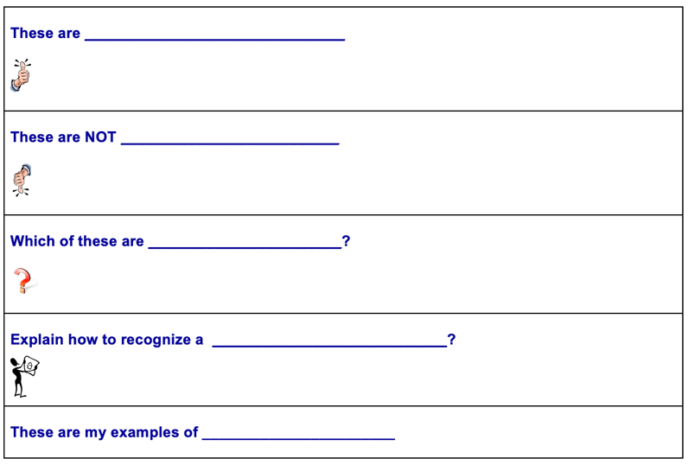 | 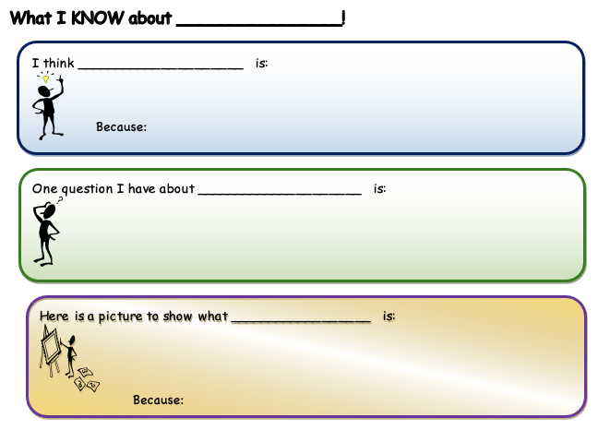
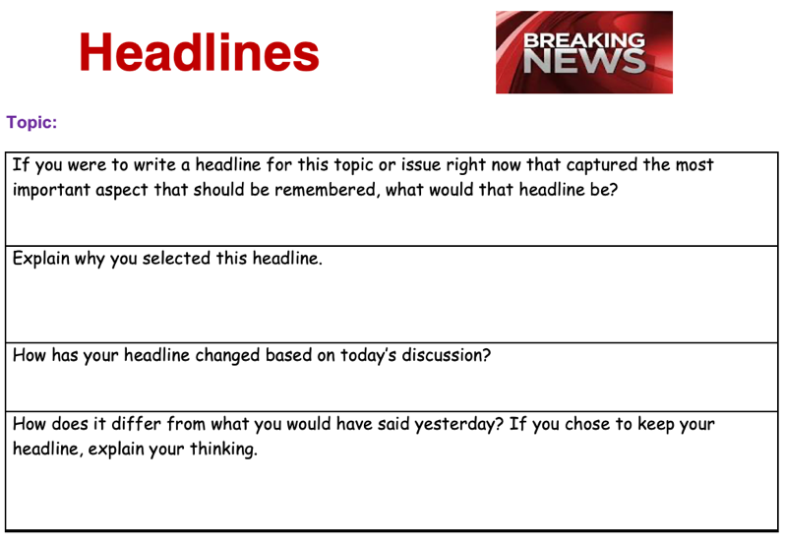 | 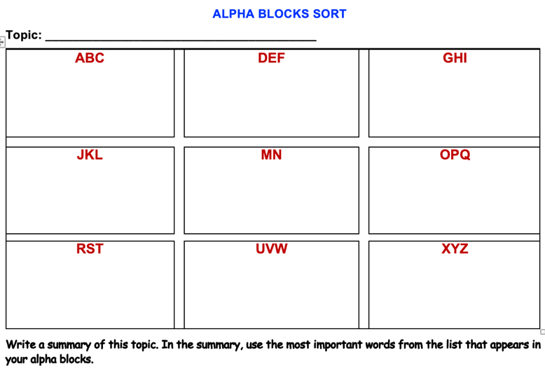
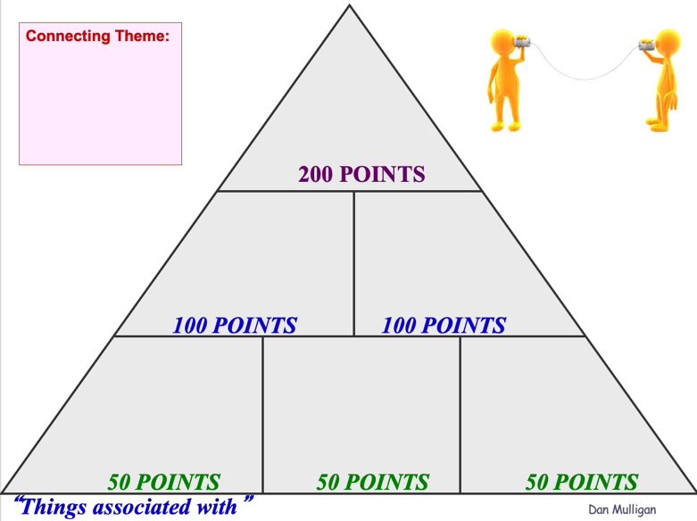 | 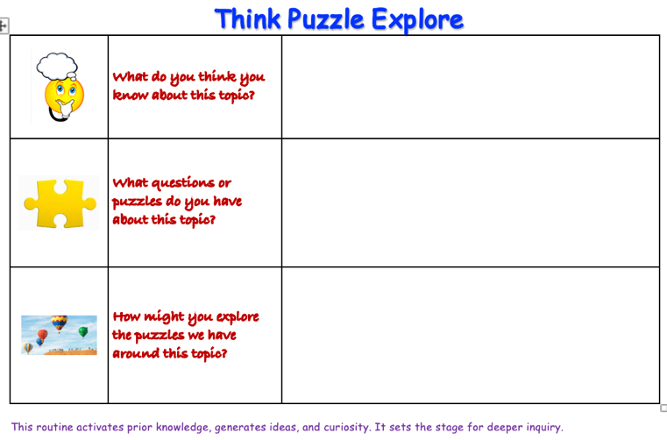

*Constantly responding to checks for understanding (differentiation)*
Develop Student Understanding
This is the teaching/learning/discovering phase. Multiple checks for understanding along the way. Facilitating discovery, modeling, Guided Practice, Independent Practice

Helping Students Develop Understanding
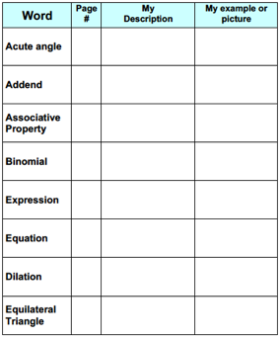 | 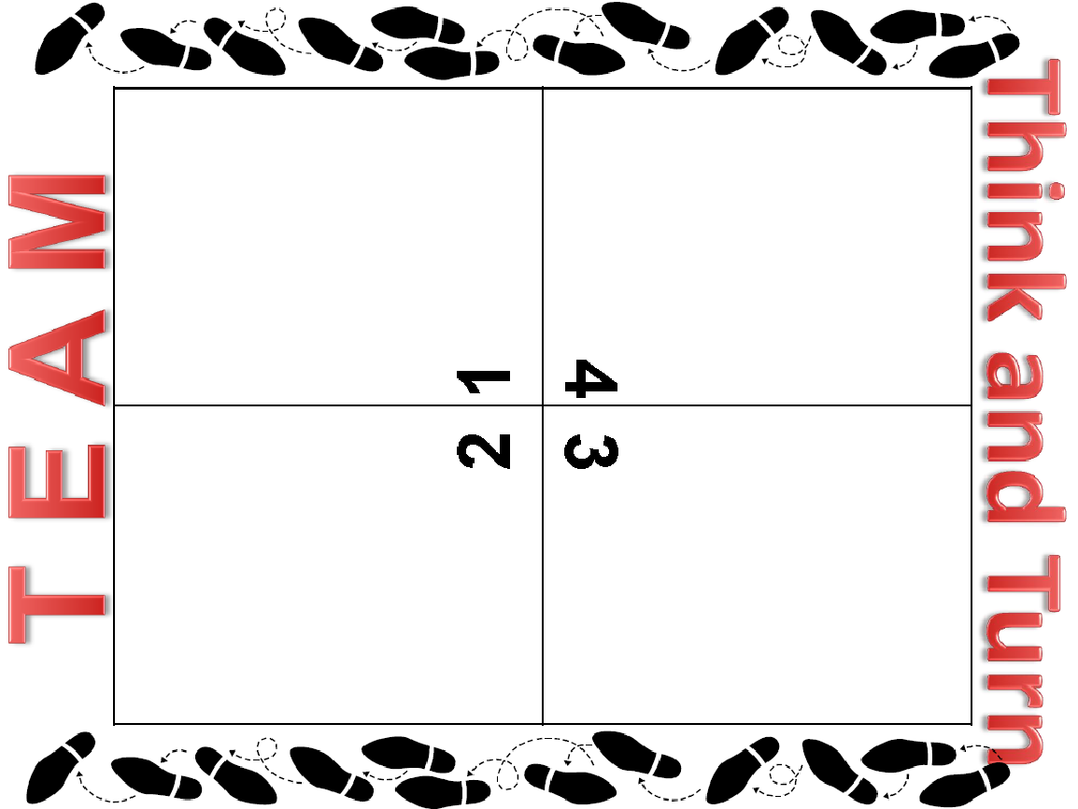
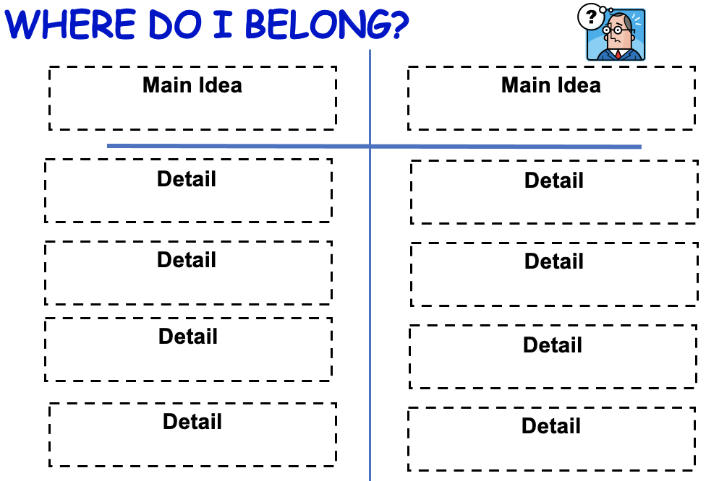 | 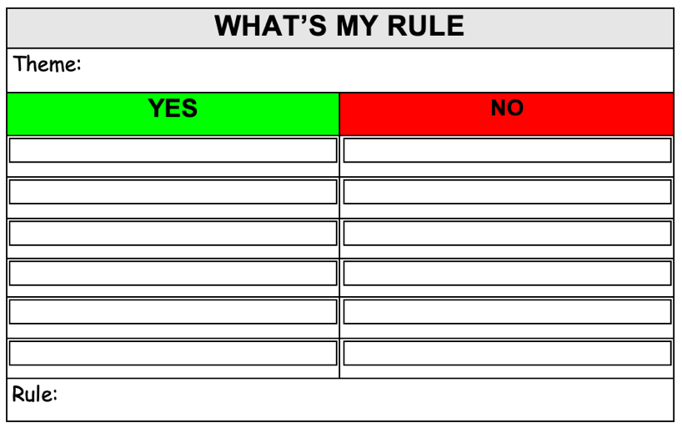
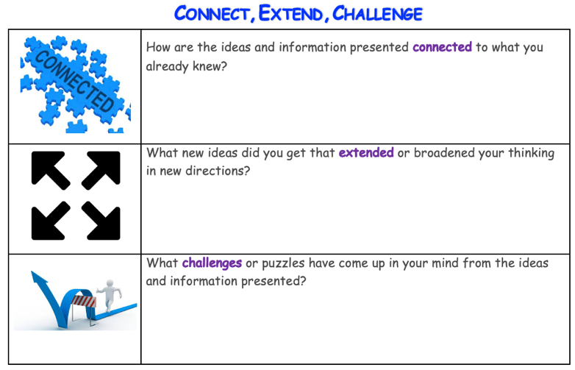 | 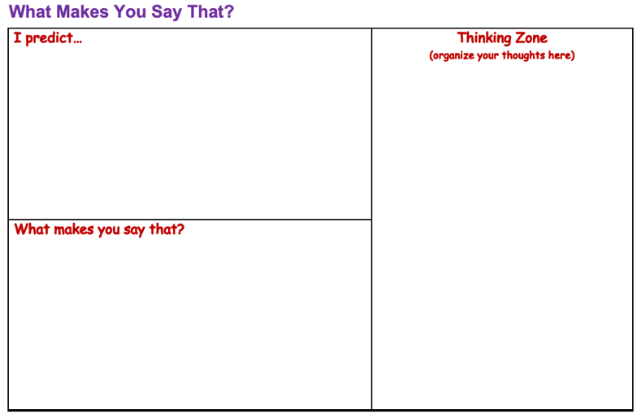

*Constantly responding to checks for understanding (differentiation)*
Facilitate Student-Centered Closure
Student reflection & doing something with what they learned.

Helping Students Extend and Apply Knowledge
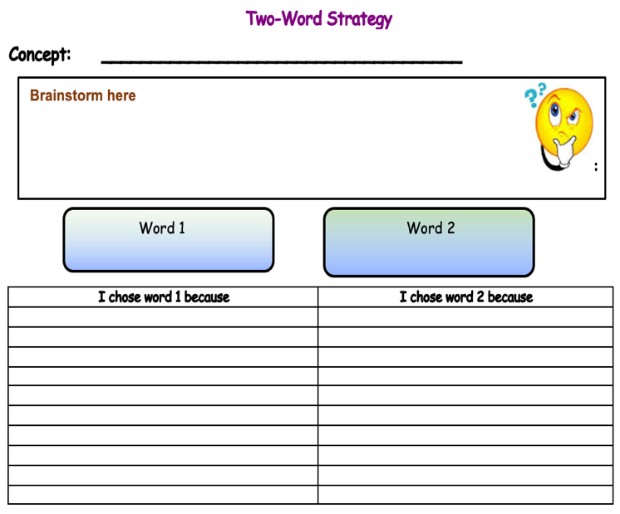 | 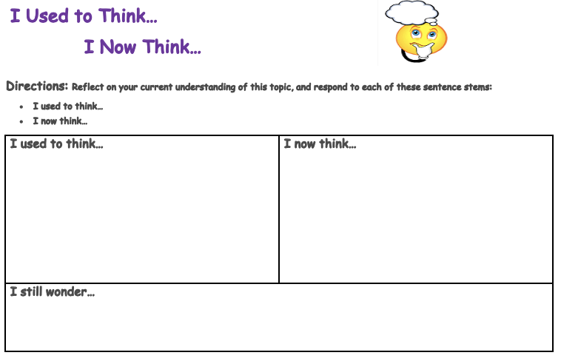
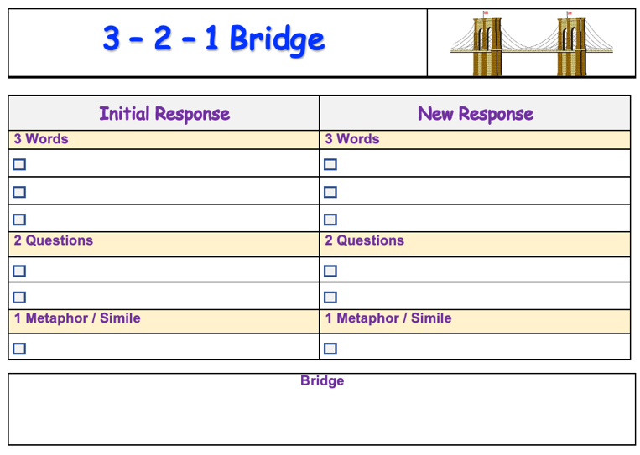 | 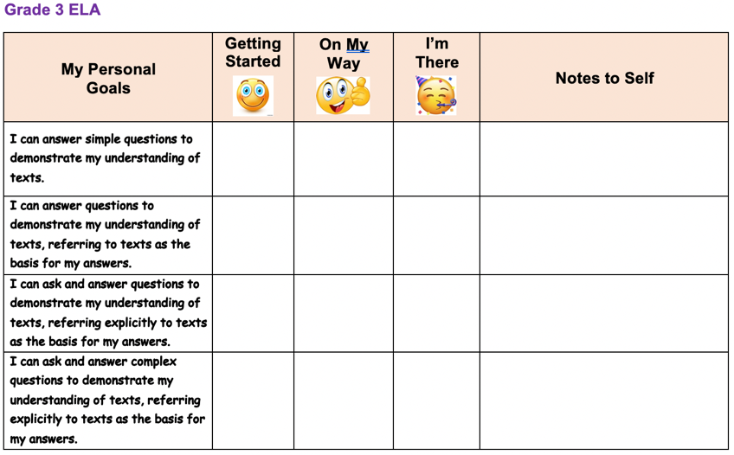
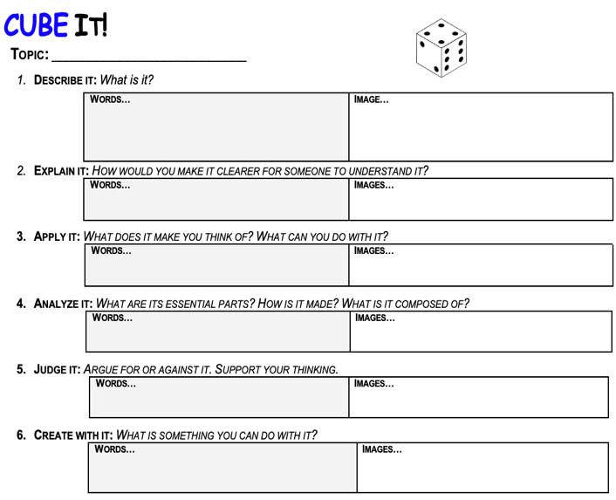 | 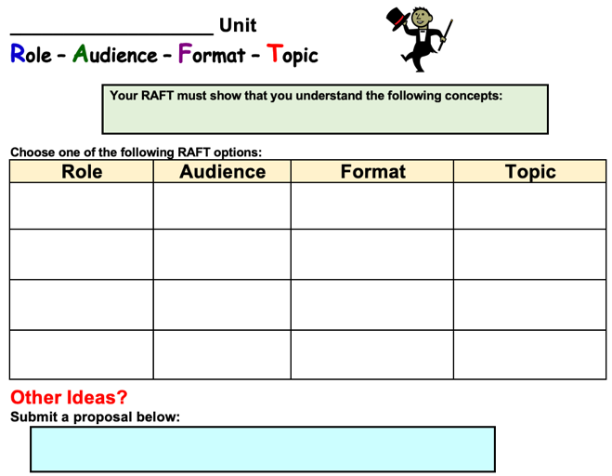

Elements of Effective Learning
What instructional strategies will produce the best results for each learner?
Lesson Planning Guide
Lesson Phase | How I will guide my students
Understand a Clear Objective (Essential Question) /Vocabulary
Referenced by teacher/students throughout learning
Activate Student Background Knowledge
Provides students with context
Allows teacher to build/check for background knowledge
Develop Student Understanding
Reimagine the ‘I do’ role; teaching/learning/discovering phase. Multiple checks for understanding along the way. Facilitating discovery, modeling, Guided Practice, Independent Practice
Facilitate Student-Centered Closure
Student reflection & doing something with what they learned.

