**Providing a Guaranted and Viable Curriculum**

Supporting a Passion and Commitment to Educational Excellence

**Unwrap a Standard: *What do students have to know and be able to do?***

**Domain: Functions**

**Domain Weight:** 21% -55% of AASA items, 19% of course standards

(DOK1:10-20%, DOK2: 60-70%; DOK3: 12-30%)

**Standard: 8.F.A.3** Interpret the equation y = mx + b as defining a linear function, whose graph is a straight line; give examples of functions that are not linear. For example, the function A = s2 giving the area of a square as a function of its side length is not linear because its graph contains the points (1,1), (2,4) and (3,9), which are not on a straight line.

|  |  |  |  |
| --- | --- | --- | --- |
| **Emerging (1)** | **Developing (2)** | **Proficient (3)** | **Distinguished (4)** |
| I can identify the slope and y-intercept of a line given an equation. | I can rewrite a standard linear equation in slope-intercept form. | I can interpret the equation y = mx + b as defining a linear function whose graph is a straight line.  I can give examples of functions that are not linear. | I can write the equation y = mx + b for a graph that is a straight line.  I can apply my understanding of functions that are linear and functions that are not linear to practical situations. |

|  |
| --- |
| **Flashback Standard: 7.EE.1** Apply the properties of operations as strategies to add, subtract, factor, and expand linear expressions with rational coefficients. |



|  |  |
| --- | --- |
| **Essential Knowledge/Concepts**  ***What Do Students Need to Know/Understand?***  **List the underlined nouns.**  **FS**  **PS** | **Essential Skills**  ***What Do Students Need to Be Able to Do?***  **List the circled (or *italicized*) verbs.**    **FS**  **PS** |
| **DOK Level**  **Level of content complexity rather than content difficulty.** |
| **Wonder Questions**  ***How can we capture student wonder?***  **\*Including open-ended and ‘second’ questions** | **Essential Vocabulary**  ***What Do Students Need to Comprehend?***  **List all key vocabulary**  **FS**  **PS** |
| **Learning Objectives aligned to the Standard**  ***What ‘I can’ statement(s) will clarify the objective for students?*** | |
| **Evidence of Student Mastery?**  ***How will we know when they know it?*** | |
| **Specific Instructional Framework?**  ***What will we do to help them know/understand/can do it?***  ***What will we do for students who still don’t know it?***  ***What will we do for students who already know it?*** | |

**Pima Unified School District**

Supporting a Passion and Commitment to Educational Excellence

**Unwrap a Standard: *What do students have to know and be able to do?***

**Domain: Functions**

**Domain Weight:** 21% -55% of AASA items, 19% of course standards

(DOK1:10-20%, DOK2: 60-70%; DOK3: 12-30%)

**Standard: 8.F.3 Interpret** the equation y = mx + b as defining a linear function, whose graph is a straight line; **give** examples of functions *that are not* linear. For example, the function A = s2 giving the area of a square as a function of its side length is not linear because its graph contains the points (1,1), (2,4) and (3,9), which are not on a straight line.

|  |  |  |  |
| --- | --- | --- | --- |
| **Emerging (1)** | **Developing (2)** | **Proficient (3)** | **Distinguished (4)** |
| I can **identify** the slope and y-intercept of a line given an equation. | I can **rewrite** a standard linear equation in slope-intercept form. | I can **interpret** the equation y = mx + b as defining a linear function whose graph is a straight line.  I can **give** examples of functions that are not linear. | I can **write** the equation y = mx + b for a graph that is a straight line.  I can **apply** my understanding of functions that are linear and functions that are not linear to practical situations. |

|  |
| --- |
| **Flashback Standard: 7.EE.1** **Apply** the properties of operations as strategies to **add**, **subtract**, **factor**, and **expand** linear expressions with rational coefficients. |



|  |  |
| --- | --- |
| **Essential Knowledge/Concepts**  ***What Do Students Need to Know/Understand?***  **List the underlined nouns.**  Equation of line Slope y-intercept  Linear Function Graph Points Undefined  Rate of Change Positive. Negative Zero  Coordinates Integers Vertical Horizontal  Transformation Point on the line Function  **FS**  Linear Expression Rational Coefficient  **PS**  Linear Quadratic Exponential  Equations Functions Scales Coordinate | **Essential Skills**  ***What Do Students Need to Be Able to Do?***  **List the circled (or *italicized*) verbs.**  **Interpret Give (Create) Identify**  **Rewrite Write Apply**  **FS Apply Add Subtract Factor**  **Expand**  **PS Create Graph** |
| **DOK Level**  **Level of content complexity rather than content difficulty.**  **DOK 1 DOK 2 DOK 3** |
| **Wonder Questions**  ***How can we capture student wonder?***  **\*Including open-ended and ‘second’ questions**   * + In what situations could rate of change be less than zero? In what situations could rate of change be greater than zero?   + Are there any practical situations where the *y*-intercept would be negative? Why or why not?   + How could you use a graph of an equation to make predictions? | **Essential Vocabulary**  ***What Do Students Need to Comprehend?***  **List all key vocabulary**  Equation of line Linear Equation Graph  Points Undefined Rate of Change  Positive Negative Zero Coordinates  Integers Vertical Horizontal  **FS** Linear Expression Rational Coefficient  **PS** Linear Quadratic Exponential |
| **Learning Objectives aligned to the Standard**  ***What ‘I can’ statement(s) will clarify the objective for students?*** | |
| **Evidence of Student Mastery?**  ***How will we know when they know it?*** | |
| **Specific Instructional Framework?**  ***What will we do to help them know/understand/can do it?***  ***What will we do for students who still don’t know it?***  ***What will we do for students who already know it?*** | |

**Evidence of Student Mastery?**

***How will we know when they know it?***

**Item #1**: Alignment to ALD: 8.F.3.**0** (Flashback to **7.EE.1**)

Which expressions are equivalent to 2 + 2m + m + 6 + m ?

1. 4(m + 2)
2. 2(2 +2m)
3. 8 + 2m
4. 12m

**Item #2**: Alignment to ALD: 8.F.3.**1**

Use the following linear equation to answer each part of the question.

$$y= \frac{2}{3} x-7$$

**Part A.** What is the slope of this function?

**Part B.** What does the slope tell us about this function?

**Part C.** What is the y-intercept of this function?

**Part D.** What does the y-intercept tell us about this function?

**Item #3**: Alignment to ALD: 8.F.3.**2**

The linear equation below is in standard form.

5x + 3y = 15

**Part A.** Rewrite it in slope-intercept form. Show your thinking.

**Part B.** Use the slope-intercept form to graph the linear equation.

**Item #4**: Alignment to ALD: 8.F.3.**3**

The function *y* = 20.25*x* + 5 represents the total cost, *y* dollars, of buying *x* tickets to a concert.

**Part A.** Is this a linear function?

**Part B.** Explain your answer with sentences and/or a graph.

**Item #5:** Alignment to ALD: 8.F.3.**3**

Jerome wants the graph of the equation y = xn + to be a linear equation.

**Part A.** What must be the value of n if his equation is to be linear?

**Part B.** Create an equation with a different value of n that result in a graph that is not linear.

**Part C.** State and graph three ordered pairs from the non-linear equation to verify your answer from Part B.

**Item #6**: Alignment to ALD: 8.F.3.**3**

Use the following equation to answer each part of the question.

$$y= \frac{x^{3}}{3}+5$$

**Part A.** Is the equation linear or nonlinear?

**Part B.** Justify your response to Part A.

**Item #7**: Alignment to ALD: 8.F.3.**3**

**Part A.** When graphed, which situation’s data would be linear?

1. The temperature of the roof of a house every hour for 24 hours.
2. A person’s body temperature every hour for a year.
3. The temperature of water rising 3°F every hour.
4. The daily temperature of a city for a year.

**Part B.** Explain how you were able to identify which situation was linear.

**Item #8**: Alignment to ALD: 8.F.3.**4**

**Part A.** Write the equation of the line shown in the graph below.

**Part B.** Show your thinking.

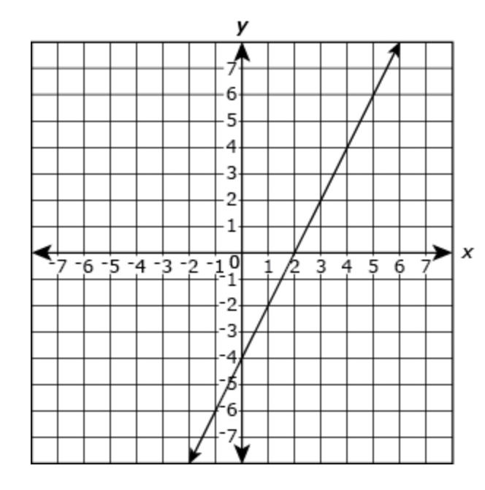

**Item #9**: Alignment to ALD: 8.F.3.**4**

Suppose a [maglev train](https://www.energy.gov/articles/how-maglev-works) travels a long distance and maintains a constant speed of 83 meters per second for a period of time once it is 250 meters from the station. How can we analyze the train’s distance from the station as a function of time? In this section, we will investigate a kind of function that is useful for this purpose and use it to investigate real-world situations such as the train’s distance from the station at a given point in time.

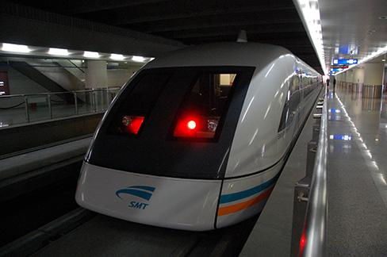

**Every Student, Every Day, No Excuses**

***Student Personal Goals to Celebrate and Chart Progress***

|  |  |  |  |  |
| --- | --- | --- | --- | --- |
| **My Learning Goal** | **Getting Started** | **On My Way** | **I’m There** | **Notes to Self** |
| I can identify the slope and y-intercept of a line given an equation. |  |  |  |  |
| I can rewrite a standard linear equation in slope-intercept form. |  |  |  |  |
| I can interpret the equation y = mx + b as defining a linear function whose graph is a straight line. |  |  |  |  |
| I can give examples of functions that are not linear. |  |  |  |  |
| I can write the equation y = mx + b for a graph that is a straight line. |  |  |  |  |

**Guided Group Lesson**

**Standard: 8.F.3**

**Interpret** the equation y = mx + b as defining a linear function, whose graph is a straight line; **give** examples of functions *that are not* linear. For example, the function A = s2 giving the area of a square as a function of its side length is not linear because its graph contains the points (1,1), (2,4) and (3,9), which are not on a straight line.

|  |  |  |  |  |
| --- | --- | --- | --- | --- |
| Group Members | Emerging | Developing | Proficient | Distinguished |
|  |  |  |  |

Warm-Up:

|  |
| --- |
| Place students in pairs. Have them play a game of ‘Battleship’ with slope and y-intercept. Each student has a 10x10 grid to graph a linear function with integer slope and y-intercept. Place a divider between the grids. Students must ask questions of their partner to determine their partner’s linear equation and resulting graph. |



Vocabulary



|  |  |  |  |
| --- | --- | --- | --- |
| Emerging | Developing | Proficient | Distinguished |
| Students play a game of ‘Guess the Mystery Line’. Students are provided clue cards to determine the standard form of a linear equation. Clues can include graphs, points on a line, and/or the slope and a point on a line.  *Provide a simple gameboard to allow students to move a certain number of spots based on each correct answer. | Pairs of students use their Think Pads to record their predictions of ‘Linear Function’, ‘Function but not Linear’, or ‘Not a Function’ using a Where Do I Belong chart that includes a fourth column labeled, ‘What makes me say this’. | Students are directed to <https://www.allconnect.com/internet>  Have students enter their local zip code and compare rates of change in cost of plans between two providers. Justify which plan is the best by providing the rate of change and include a graph of the plans on the same grid. Ask students to provide three examples for each chosen plan to determine cost to the customer. | Newton County, Georgia's [estimated population](https://www.census.gov/quickfacts/newtoncountygeorgia) is 116,390 with a **growth rate of 2.04%** in the past year according to the most recent United States census data. Newton County, Georgia is the 24th largest county in Georgia. The 2010 Population was 100,133 and has seen a growth of 16.24% since this time. Assuming a constant annual growth rate, write the linear function to represent Newton’s annual growth rate. What will be the population in 2040? |

|  |  |  |
| --- | --- | --- |
| Observations: |  | Next Steps: |
| What you notice about your students during small group instruction. | What will you do with these students next? Change groups, repeat, etc. |