Providing Pathways to Excellence for Each Student
MATH 3
Unwrap a Standard: What do students have to know and be able to do?

Domain: Geometry (Reason with shapes and their attributes.)
Domain/Reporting Category Weight (if applicable): 1 – 4%

Standard: 3.G.A.2 (Pre-assessment Fast 5 for Unit 5)
Partition shapes into b parts with equal areas. Express the area of each part as a unit fraction 1/b of the whole. (Grade 3 expectations are limited to fractions with denominators b = 2,3,4,6,8.)

Performance/Achievement Level Descriptors
Emerging (1) | Developing (2) | Proficient (3) | Distinguished (4)
I can partition shapes into b parts with equal areas.  I can express the area of each part as a unit fraction 1/b of the whole. (limited to halves and quarters). | I can partition shapes into b parts with equal areas.  I can express the area of each part as a unit fraction 1/b of the whole. (limited to halves, quarters, and eighths). | I can partition shapes into b parts with equal areas.  I can express the area of each part as a unit fraction 1/b of the whole. I can justify my reasoning. (Grade 3 expectations are limited to fractions with denominators b = 2,3,4,6,8.) | I can partition shapes into parts with equal areas.  I can express the area as a unit fraction of the whole to answer questions presented in a context.
Building Background Knowledge and skills: Flashback Standard
Standard: 2.G.A.3 Partition circles and rectangles into two, three, or four equal shares, describe the shares using the words halves, thirds, fourths, half of, third of, fourth of, and describe the whole as two halves, three thirds, or four fourths. Recognize that equal shares of identical wholes need not have the same shape.
Preview Standard: 4.NF.B.4 Build fractions from unit fractions.
a. Understand a fraction $\frac{a}{b}$ as a multiple of a unit fraction$\frac{1}{b}$. In general, $\frac{a}{b}$ = a x $\frac{1}{b}$.
b. Understand a multiple of $\frac{a}{b}$ as a multiple of a unit fraction$\frac{1}{b}$, and use this understanding to multiply a whole number by a fraction. In general, n x $\frac{a}{b}$ = $\frac{n x a}{b}$.
c. Solve word problems involving multiplication of a whole number by a fraction.

Providing Pathways to Excellence for Each Student
MATH 3
Unwrap a Standard: What do students have to know and be able to do?

Domain: Geometry (Reason with shapes and their attributes.)
Domain/Reporting Category Weight (if applicable):

Standard: 3.G.A.2
Partition shapes into b parts with equal areas. Express the area of each part as a unit fraction 1/b of the whole. (Grade 3 expectations are limited to fractions with denominators b = 2,3,4,6,8.)

Performance/Achievement Level Descriptors
Emerging (1) | Developing (2) | Proficient (3) | Distinguished (4)
I can partition shapes into b parts with equal areas.  I can express the area of each part as a unit fraction 1/b of the whole. (limited to halves and quarters). | I can partition shapes into b parts with equal areas.  I can express the area of each part as a unit fraction 1/b of the whole. (limited to halves, quarters, and eighths). | I can partition shapes into b parts with equal areas.  I can express the area of each part as a unit fraction 1/b of the whole. I can justify my reasoning. (Grade 3 expectations are limited to fractions with denominators b = 2,3,4,6,8.) | I can partition shapes into parts with equal areas.  I can express the area as a unit fraction of the whole to answer questions presented in a context.
Building Background Knowledge and skills: Flashback Standard
Standard: 2.G.A.3 Partition circles and rectangles into two, three, or four equal shares, describe the shares using the words halves, thirds, fourths, half of, third of, fourth of, and describe the whole as two halves, three thirds, or four fourths. Recognize that equal shares of identical wholes need not have the same shape.
Preview Standard: 4.NF.B.4 Build fractions from unit fractions.
a. Understand a fraction $\frac{a}{b}$ as a multiple of a unit fraction$\frac{1}{b}$. In general, $\frac{a}{b}$ = a x $\frac{1}{b}$.
b. Understand a multiple of $\frac{a}{b}$ as a multiple of a unit fraction$\frac{1}{b}$, and use this understanding to multiply a whole number by a fraction. In general, n x $\frac{a}{b}$ = $\frac{n x a}{b}$.
c. Solve word problems involving multiplication of a whole number by a fraction.

Essential Knowledge/Concepts  What Do Students Need to Know/Understand?  List the underlined nouns.  Shape Part Whole Area Perimeter Partition  Unit Fraction Halves Thirds Fourths (quarters)  Sixths Eighths  FB Partition Circle Rectangle Equal Shares  Halves Thirds Fourths Identical Wholes | Essential Skills  What Do Students Need to Be Able to Do?  List the circled (or italicized) verbs.  Partition Express Justify  FB Partition Describe Recognize
DOK Level
Level of content complexity rather than content difficulty.

DOK 1 DOK 2 DOK 3
WONDER Questions  How can we capture student wonder?  *Including open-ended and ‘second’ questions  - Is it possible to find more than 1 way for shapes to fit together to make another shape?  - What does it mean to partition a shape into parts?  - What do you know about pattern blocks that would help me understand how to fill an area?  - What is the purpose of studying fractions?  - How do you know if a shape shows _____ (halves, thirds, fourths, sixths, or eighths?)  - Describe what a fraction looks like in a shape?  - Can all shapes be split into halves, thirds, fourths, sixths, and eighths? Prove it. | Essential Vocabulary  What Do Students Need to Comprehend?  List all key vocabulary  Shape Part Whole Area Perimeter  Partition Unit Fraction Halves Thirds  Fourths (quarters) Sixths Eighths
Learning Objectives aligned to the Standard
What are the Learning Intentions and Success Criteria that will guide student progress?
I am learning to relate my fraction work to geometry by expressing the area of a shape as a unit fraction of the whole.

I am learning that shapes can be partitioned with equal areas in a variety of ways to show halves, thirds, fourths, sixths, and eighths.
Evidence of Student Mastery?
How will we know when they know it?
How will we encourage each student to try?

Specific Instructional Framework?
What will we do to help them know/understand/can do it?
What will we do for students who still don’t know it?
What will we do for students who already know it?
AASA Specifications to Assist in Creating an Aligned DCFA and Planning Learning
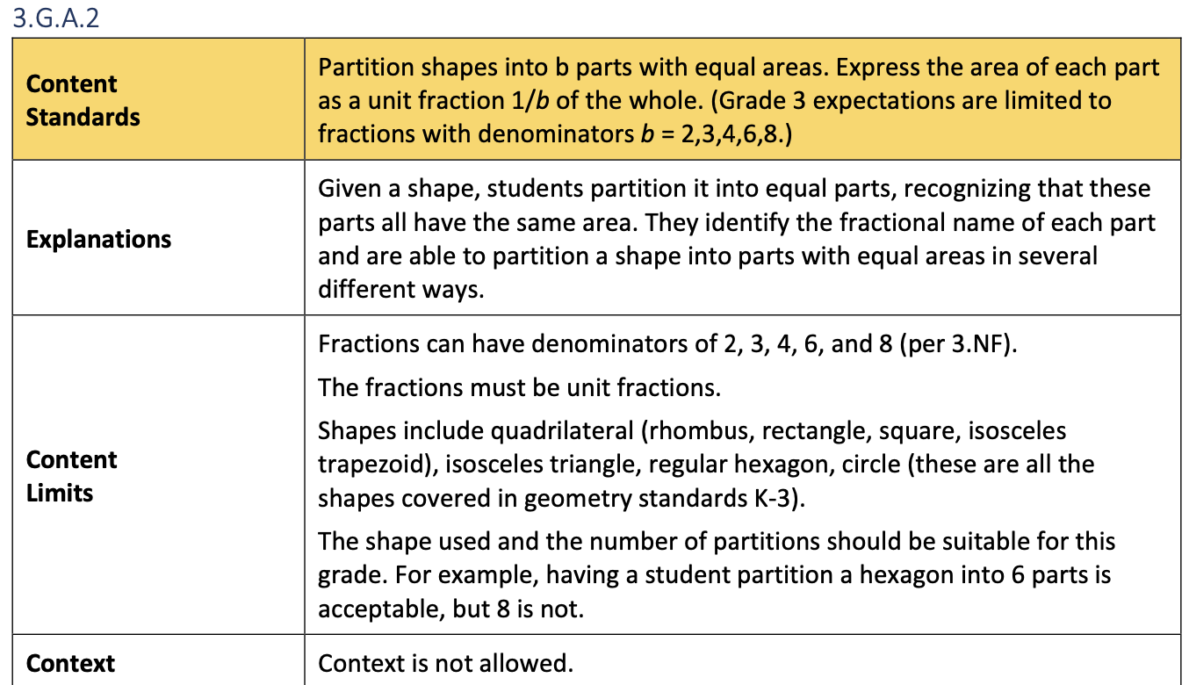

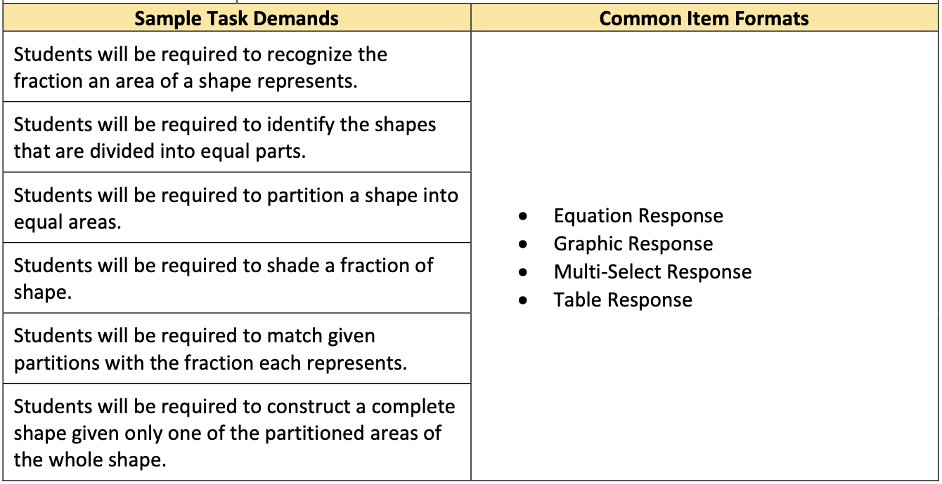

AASA Sample Items to Assist in Creating an Aligned DCFA and Planning Learning

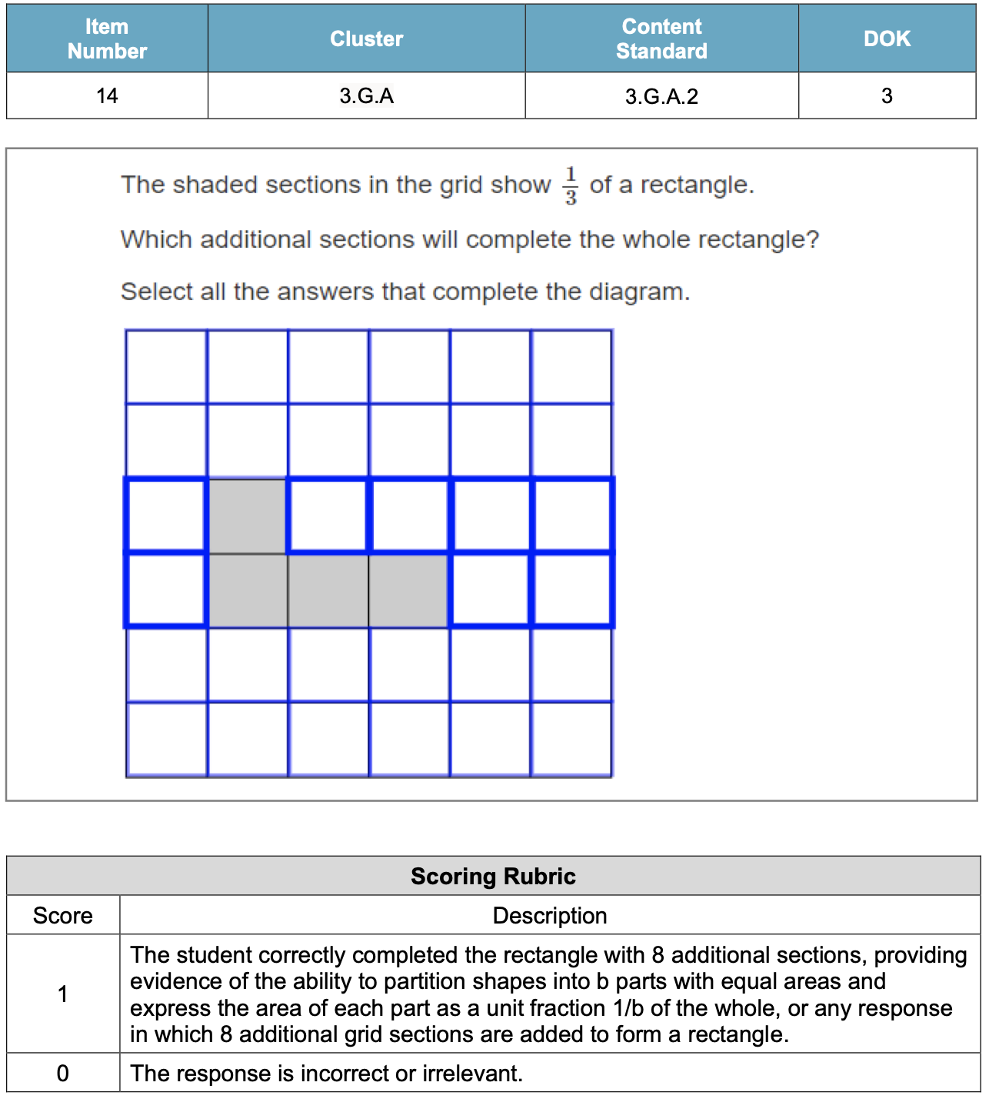

Evidence of Student Mastery?
How will we know when they know it?

Item #1: Alignment to PLD 3.G.A.2.0 (Flashback to 2.G.A.3)

PART A. Which shapes are partitioned into two equal shares.

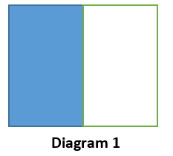 | 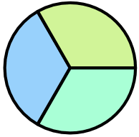 | 

PART B. Show your thinking using drawings, words, and numbers.

Item #2: Alignment to PLD 3.G.A.2.1

PART A. Partition the shape below into three equal shares.
PART B. Shade one of the equal shares.

PART C. Express the area of the shaded section as a fraction of the whole shape.

Item #3: Alignment to PLD 3.G.A.2.2

PART A. Draw a hexagon.
PART B. Partition the shape into six equal shares.
PART C. State the fraction that represents the area one share as a part of the whole shape.

Item #4: Alignment to PLD 3.G.A.2.3

The shaded section of the grid shows $\frac{1}{2}$ of a rectangle. Which additional sections will complete the whole rectangle? Draw the whole rectangle on the grid below.

Item #5: Alignment to PLD 1.G.A.3.3

PART A. Partition the rectangle below into eight squares each having the same area.
PART B. What fraction of the whole will represent the area of two of the squares?

Item #6: Alignment to PLD 5.NF.A.2.4

Pedro is baking a pie for Maria, Tomas, and himself.

PART A. Draw lines on the pie to show Pedro how he can partition the pie into three equal parts.

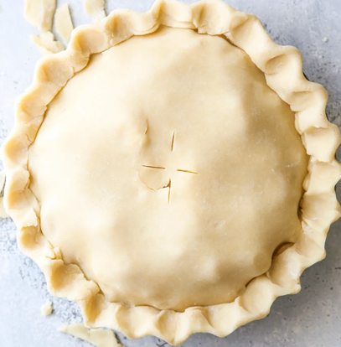

PART B. Maria said her piece represents the same fractional part of the pie as Tomas and Pedro’s pieces combined. Do you agree with Maria? Explain your thinking.

PART C. What fraction will represent Maria’s share of the pie?

PART D. What fraction will represent Tomas and Pedro’s share combined?

Step 4:
Create a My Personal Goals Chart for each student to note their progress with each success criteria.

My  Success Criteria | Getting Started   | On My Way   | I’m There   | Notes to Self
I can partition shapes into b parts with equal areas.
I can express the area of each part as a unit fraction 1/b of the whole. (limited to halves and quarters).
I can express the area of each part as a unit fraction 1/b of the whole. (limited to halves, quarters, and eighths).
I can express the area of each part as a unit fraction 1/b of the whole. (Grade 3 expectations are limited to fractions with denominators b = 2,3,4,6,8.)
I can express the area as a unit fraction of the whole to answer questions presented in a context.

Step 5:
Collaboratively determine small group experiences to move each student toward proficiency and beyond.

Guided Group Lesson Date:

Standard:

Group Members | Emerging | Developing | Proficient | Distinguished

Warm-Up:
Pairs of students work as a team to play “I Have, Who Has?” with the class. This task will help students further develop their understanding of partitioning shapes into parts with equal area by using halves, thirds, fourths, sixths, and eighths. Extension: Students create their own game. (see attached sample)

Vocabulary
Shape Part Whole Area Perimeter Partition Unit Fraction

Halves Thirds Fourths (quarters). Sixths Eighths

Emerging | Developing | Proficient | Distinguished
Lesson focus:  Pattern Block Mystery: Students will use pattern blocks to partition shapes into different shapes.  Students will justify their solution by drawing pictorial representations of their solutions. | Lesson focus:  Make a poster that shows shapes partitioned into equal areas of half, thirds, fourths, sixths, and eighths. Remember to show a variety of shapes and show the same shape partitioned in several ways.  What do you notice about the size of each piece as you increase the number of pieces in the same whole. | Lesson focus:  Farmer Gutierrez is building a rectangular stable to hold six horses. Each horse needs their own stall of the same size.  Draw a picture to help Mr. Gutierrez with his project. What fractional part of the whole building is each stall?  Mr. Gutierrez buys two additional horses. Draw a new picture to redesign his stable. What fractional part of the whole building is each stall?  Is each new stall larger or smaller than the original stall? Why is this true? | Lesson focus:  A regular dodecagon is a ten-sided polygon with equal sides.  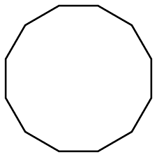  Draw triangles to divide the shape into equal shares. What fraction can be used to represent each triangle. Can we partition the shape into five larger triangles? What fraction would represent each piece.

Observations: |  | Next Steps:
What you notice about your students during small group instruction. |  | What will you do with these students next? Change groups, repeat, etc.

I Have, Who Has? (Adapted from Mathwire.com’s Game I have, Who Has?)
Notes to the Teacher: This task is provided to assist students further develop their understanding of partitioning shapes into parts with equal area by using halves, thirds, fourths, sixths, and eighths.
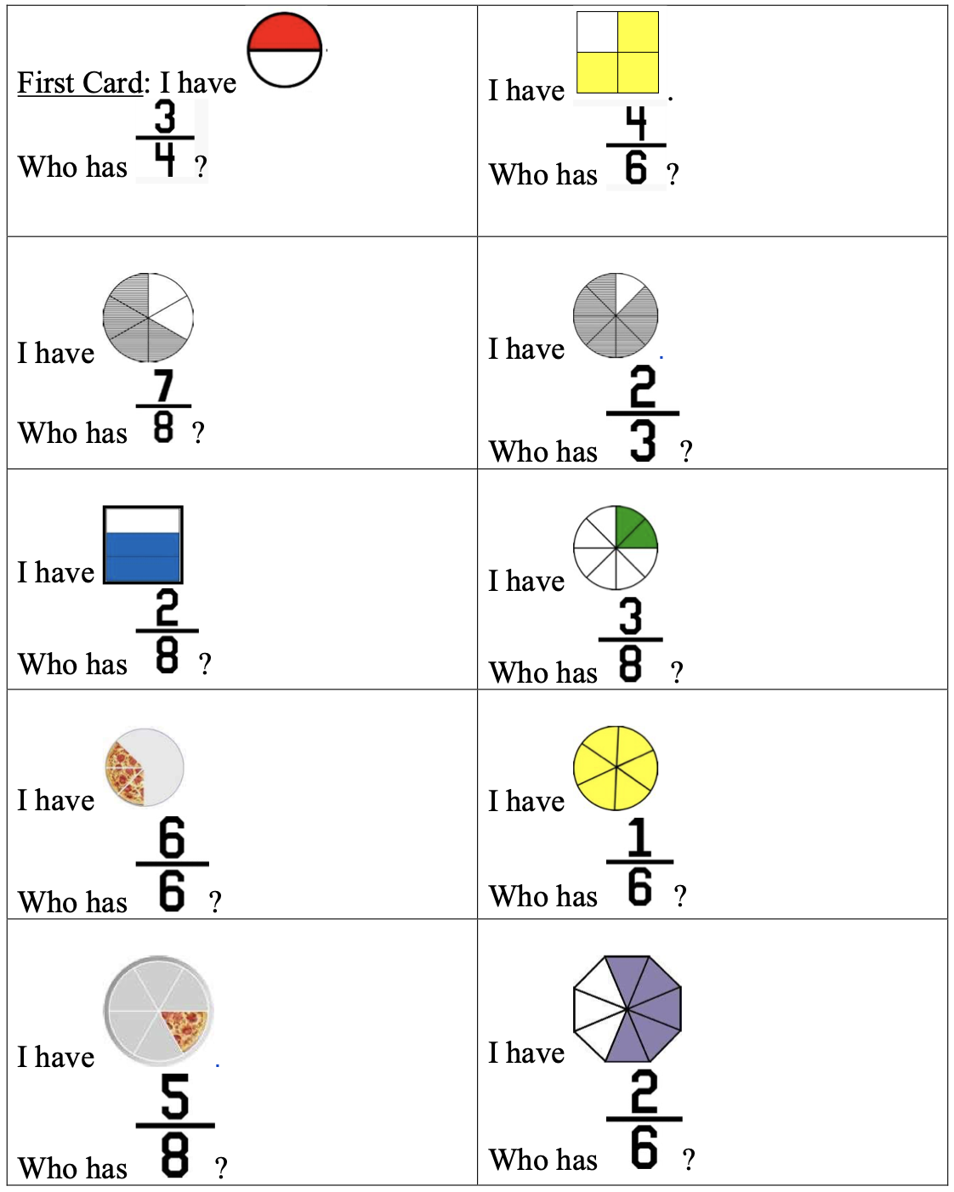
Pattern Block Mystery

