Grade 5 Math
Diagnostic Formative Assessment

Unwrap a Standard: What do students have to know and be able to do?

Domain: Numbers and Operations - Fractions
Domain Weight: 29% - 33% of AASA assessment items
Standard: 5.NF.A.2 Solve word problems involving addition and subtraction of fractions referring to the same whole, including cases of unlike denominators by using a variety of representations, equations, and visual models to represent the problem. Use benchmark fractions and number sense of fractions to estimate mentally and assess the reasonableness of answers (e.g. recognize an incorrect result 2/5 + 1/2 = 3/7, by observing that 3/7 < 1/2).
Emerging (1) | Developing (2) | Proficient (3) | Distinguished (4)
I can identify the solution to word problems involving addition and subtraction of fractions referring to the same whole, by using visual models to represent the problem.  I can use benchmark fractions and number sense of fractions to identify an estimate. | I can identify the solution to word problems involving addition and subtraction of fractions referring to the same whole, including cases of unlike denominators by using a variety of representations, equations, and visual models to represent the problem.  I can use benchmark fractions and number sense of fractions to identify an estimate and assess the reasonableness of answers. | I can solve word problems involving addition and subtraction of fractions referring to the same whole, including cases of unlike denominators by using a variety of representations, equations, and visual models to represent the problem.  I can use benchmark fractions and number sense of fractions to estimate mentally and assess the reasonableness of answers (e.g., recognize an incorrect result 2/5 + 1/2 = 3/7, by observing that 3/7 < 1/2). | I can create word problems involving addition and subtraction of fractions referring to the same whole, including cases of unlike denominators.  I can explain how to estimate mentally and assess the reasonableness of answers.
Flashback Standard: 4.NF.A.2 Compare two fractions with different denominators (e.g., by creating common denominators or numerators and by comparing to a benchmark fraction)
Preview Standard: 5.MD.B.2 Make a line plot to display a data set of measurements in fractions of a unit (1/8, ½, ¾)
Arizona Performance Level Descriptors G.A.1 (EQR,MCR)

Additional AZ resources for unpacking: 5.NF.A.2

AASA Item Specifications:
Explanations | Estimation skills include identifying when estimation is appropriate, determining the level of accuracy needed, selecting the appropriate method of estimation, and verifying solutions or determining the reasonableness of situations using various estimation strategies. Estimation strategies for calculations with fractions extend from students’ work with whole number operations and can be supported through the use of physical models.
Content Limits | Improper fractions and mixed numbers included.  Least common denominator is not necessary to calculate sums of fractions. Do not use the terms "simplify" or "lowest terms".
Context | Context is required.

Sample Task Demands | Common Item Formats
Students will be required to calculate the sum or difference of two or more fractions with like and/or unlike denominators in a given word problem. | - Equation Response (EQR)  - Multiple Choice Response (MCR)
Students will be required to determine a missing numerator or denominator in the addend, subtrahend, or minuend of an addition or subtraction problem with fractions in a given word problem.
Students will be required to use benchmark fractions to explain why an assertion is or is not reasonable.

Sample AASA Items
Focus  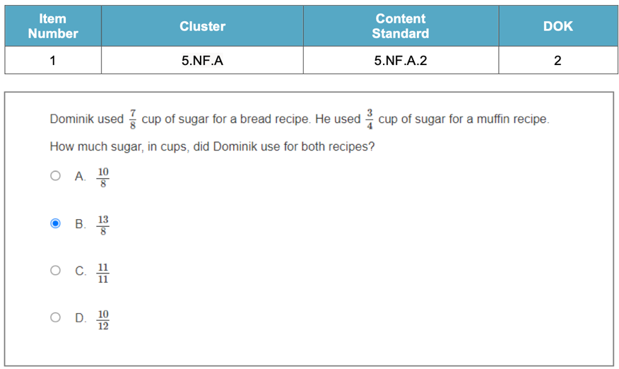 | Flashback  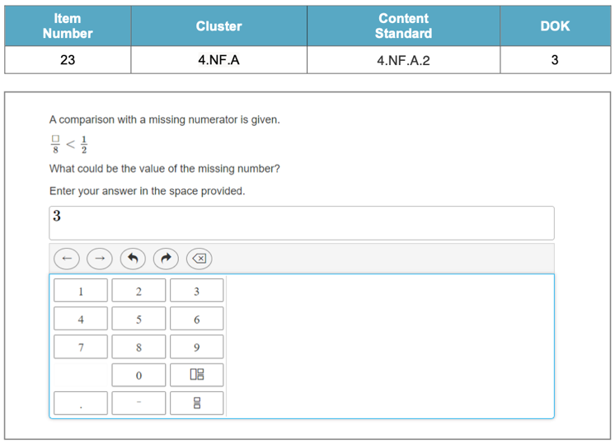

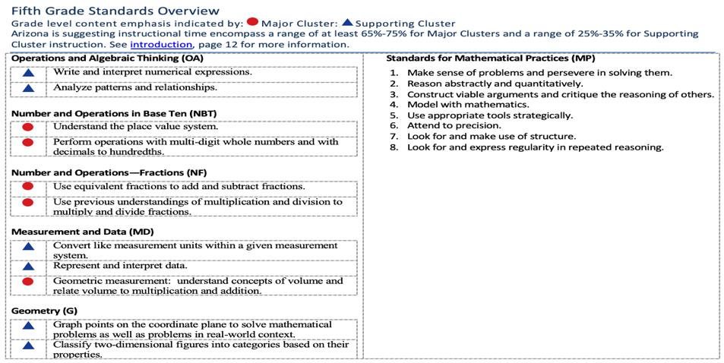
Arizona
suggests 65% - 75% of instructional time on major cluster content, skills, and vocabulary.
Arizona
Major
Clusters
Essential Knowledge/Concepts  What Do Students Need to Know/Understand?  List the underlined nouns  Fraction Numerator Denominator Part  Part Whole Estimation Reasonableness  Improper Fraction Proper Fraction  Mixed Number  FBS: Benchmark Fraction  PRS: Line Plot Unit Fraction. | Essential Skills  What Do Students Need to Be Able to Do?  List the circled (or italicized) verbs  Identify Understand Explain Recognize  Estimate Demonstrate Create  PRS: Classify
DOK Level
Level of content complexity rather than content difficulty.

DOK 1 DOK 2 DOK 3
Essential Questions  How can we capture student wonder?  *Including open-ended and ‘second’ questions  Have you ever shared a pizza or a cake with your friends? How did you decide how much each person gets?  Can ¼ be larger than ½ ? Explain your thinking.  Explain how shading or partitioning a visual model represents the addition or subtraction of fractions? | Essential Vocabulary  What Do Students Need to Comprehend?  List all key vocabulary  Fraction Numerator Denominator Part  Whole Estimate Reasonableness Proper  Mixed Number Common Denominator  Least Common Denominator Model  Sum Difference Number Line
Learning Objectives aligned to the Standard
What are the Learning Intentions and Success Criteria that will guide student progress?

See attached visible learning chart (LISCAZ5.NF.2)
Evidence of Student Mastery?
How will we know when they know it?

See attached Diagnostic Quick Check (DFA AZ5.NF.2)
Specific Instructional Framework?
What will we do to help them know/understand/can do it?
What will we do for students who still don’t know it?
What will we do for students who already know it?

Evidence of Student Mastery?
How will we know when they know it?

Item #1: Alignment to ALD 5.NF.A.2.0 (Flashback to 4.NF.A.1)

Which expression represents a way to create a fraction equivalent to $\frac{4}{5}$ ?
- $\frac{4}{5}$ + $\frac{3}{3}$ , because $\frac{3}{3}$ = 1
- $\frac{4}{5}$ x $\frac{2}{2}$ , because $\frac{2}{2}$ = 1
- $\frac{4}{5}$ + $\frac{1}{5}$ , because the sum will be 1
- $\frac{4}{5}$ x $\frac{1}{4}$ , because the numerator will stay the same

Item #2: Alignment to ALD 5.NF.A.2.1

LaTanya was making two types of cookies. One recipe needed $\frac{3}{4}$ cup of sugar and the other needed $\frac{2}{3}$ cup of sugar.
PART A. How much sugar did she need to make both recipes?
PART B. Create a visual model to represent the problem and its solution.

 | + |  | =

Item #3: Alignment to ALD 5.NF.A.2.2

Sonia had 2$\frac{1}{3}$ candy bars. She promised her brother that she would give him $\frac{1}{2}$ of a candy bar. How much will she have left after she gives her brother the amount she promised?

Item #4: Alignment to ALD 5.NF.A.2.3

Four students plan to share the cost for ordering pizza. Each student states how much of a whole pizza they want to eat, as shown.

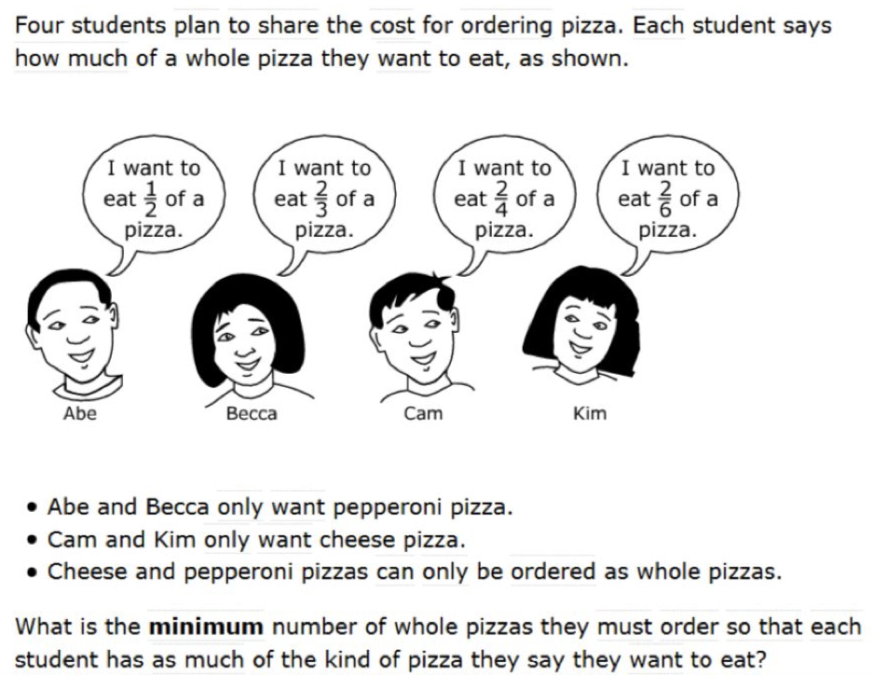

  - Abe and Rebecca only want pepperoni pizza.
  - Cam and Kim only want cheese pizza.
  - Cheese and pepperoni pizzas can only be ordered as whole pizzas.

What is the minimum number of pizzas they must order so that each student has as much of the kind of pizza they say they want to eat?

Item #5: Alignment to ALD 5.NF.A.2.3

Ellie drank $\frac{3}{5}$ quart of milk and Javier drank $\frac{1}{10}$ less than Ellie.
PART A. How much milk did they drink altogether?
PART B. Use estimation skills and words to justify the reasonableness of your answer.

Item #6: Alignment to ALD 5.NF.A.2.4

Your teacher needs your assistance in creating an application question involving addition or subtraction of fractions with unlike denominators in a real-world setting.

PART A. Create a question for your teacher.
PART B. Provide a solution and explanation to your question.

Step 4:
Create a My Personal Goals Chart for each student to note their progress with each success criteria.

My Personal Goals Chart:

Success Criteria | Getting Started | On My Way | I’m There | Notes to Self
I can identify the solution to word problems involving addition and subtraction of fractions referring to the same whole, by using visual models to represent the problem.
I can use benchmark fractions and number sense of fractions to identify an estimate.
I can identify the solution to word problems involving addition and subtraction of fractions referring to the same whole, including cases of unlike denominators by using a variety of representations, equations, and visual models to represent the problem.
I can use benchmark fractions and number sense of fractions to identify an estimate and assess the reasonableness of answers.
I can solve word problems involving addition and subtraction of fractions referring to the same whole, including cases of unlike denominators by using a variety of representations, equations, and visual models to represent the problem.
I can create word problems involving addition and subtraction of fractions referring to the same whole, including cases of unlike denominators.
I can explain how to estimate mentally and assess the reasonableness of answers.

Step 5:
Collaboratively determine small group experiences to move each student toward proficiency and beyond.

Guided Group Lesson Date:

Standard:

Group Members | Emerging | Developing | Proficient | Distinguished

Warm-Up:
With your partner, play a game of ‘Hunt for Solutions’ with each pair of fractions. Find the indicated sum or difference. With your partner, explain your thinking to your teacher, then find the Post-It note on the wall that contains your solution.

Vocabulary

Fraction Numerator Denominator Part

Whole Estimate Reasonableness Proper Mixed Number

Common Denominator Least Common Denominator Model

Sum Difference Number Line

Emerging | Developing | Proficient | Distinguished
Lesson focus:  With your partner, play a game of ‘Where Do I Belong’ by listing all the factions with unlike denominators from least to greatest. Place the fractions in the correct location on the number line. | Lesson focus:  With your team, create an Anchor Chart to show a class of Grade 4 students how to compare fractions with unlike denominators. Include an example on your chart. | Lesson focus:  With your partner, assess the accuracy of two students’ different approaches to solve the question: “Pedro ate 1/3 of a pizza and his siter ate 2/5 of the pizza. How much pizza is left? | Lesson focus:  Design a visual model to represent the expression 2/3 + 4/5. Explain how the visual model helps simplify the expression.

Observations: |  | Next Steps:
What you notice about your students during small group instruction. |  | What will you do with these students next? Change groups, repeat, etc.

Charting My Progress Reaching My Personal Goals Math 5 Individual Component Version

Learning Intention: I am learning to solve practical problems involving adding and subtracting fractions.
My Success Criteria | ? | Why am I learning This?
I can identify fractions that refer to the same whole. | I’m There  On My Way  Getting Started
I can solve practical problems involving fractions with like denominators. | I’m There  On My Way  Getting Started
I can solve practical problems with unlike denominators. | I’m There  On My Way  Getting Started
I can use different representations, equations, and visual models to solve fraction practical problems accurately. | I’m There  On My Way  Getting Started
Vocabulary:
Fraction Numerator Like Denominators Unlike denominators

Equivalent Least Common Denominator Addend Subtrahend

ELP: | Standard:  AZ 5.NF.A.2 Solve problems involving addition and subtraction of fractions referring to the same whole, including cases of unlike denominators by using a variety of representations, equations, and visual models to represent the problem.
What stuck with me? Why is it important to remember?
(include any combination of images, numbers, and words)

Where am I with applying operations with fractions?
Criteria | Distinguished | Proficient |  | Developing | Emerging
Representation and Visual Models | I accurately represent the word problem using a variety of visual models and equations. | I mostly represent the word problem using visual models. |  | I attempt to represent the word problem using visual models but with some inaccuracies. | I do not accurately represent the word problem using visual models.
Application of Addition/ Subtraction | I accurately identify the correct addition/subtraction operation and solves the problem correctly. | I correctly identify the correct addition/ subtraction operation, but I make minor errors in the solution. |  | I identify the correct addition/ subtraction operation, but I make major errors in the solution. | I struggle to identify the correct addition/subtraction operation and/or solve the problem incorrectly.
Understanding of Common Denominators | I accurately identify and apply the concept of common denominators in solving the problem. | I demonstrate a partial understanding of common denominators. |  | I attempt to apply the concept of common denominators, but with some errors. | I do not apply the concept of common denominators correctly.
Communication of Solution | I clearly and effectively communicates the solution, showing all steps and using appropriate mathematical language. | I can communicate the solution with some clarity and use some mathematical language. |  | I can communicate the solution with limited clarity and/or use minimal mathematical language. | I struggle to communicate the solution effectively and/or do not use mathematical language.
What are things I know? Explain. |  |  | What are my opportunities? Explain.

Small Group DOK Questions

Level 1 - (Recall - measure, recall, calculate, define, list, identify.)
- What is the definition of a fraction?
- List three ways to represent a fraction using a visual model.
- Identify which fraction is greater: 3/4 or 5/6.
- Calculate the sum of 1/2 and 1/3.
DOK Level 2 - Skill/Concept - graph, classify, compare, estimate, summarize.
- Graph the fractions 2/3 and 4/5 on a number line.
- Classify the fractions 1/4, 3/8, and 5/6 as proper or improper fractions.
- Compare the fractions 2/3 and 3/4. Which one is greater?
- Estimate the sum of 3/5 and 7/8 to the nearest whole number.
- Summarize the steps to find a common denominator when adding or subtracting fractions.
DOK Level 3 - (Strategic Thinking - assess, investigate, formulate, draw conclusions, construct.)
- Investigate how to find a common denominator when adding or subtracting fractions with unlike denominators.
- Formulate a strategy for solving word problems involving addition and subtraction of fractions.
- Assess the effectiveness of using visual models to solve fraction word problems.
- Draw conclusions about when it is necessary to simplify fractions when adding or subtracting them.
- Construct a real-life word problem that requires adding and subtracting fractions with unlike denominators.
DOK Level 4 - (Extended Thinking - analyze, critique, create, design, apply concepts.)
- Analyze a word problem involving the addition and subtraction of fractions and determine the appropriate strategy to solve it.
- Critique a solution to a fraction word problem to identify any errors or misconceptions.
- Create a visual representation of a fraction word problem and explain how it can be solved using equations.
- Design a set of fraction word problems that require different strategies to solve.
- Apply the concept of finding a common denominator to solve a real-world problem involving fractions.

