**Geometry**

**Diagnostic Formative Assessment**

**Understanding the Target to Create a Pathway to Excellence**

***What is it that we want our students to know and be able to do?***

**Unwrap a Standard: *What do students have to know and be able to do?***

**Reporting Category: Triangles**

**Reporting Category Weight: 29** % of SOL assessment items; **29** % of course standards

**Standard: G.8** The student will solve problems, including practical problems, involving right triangles. This will include applying

b) properties of special right triangles; and

c) trigonometric ratios.

|  |  |  |  |
| --- | --- | --- | --- |
| **Emerging** | **Developing** | **Proficient** | **Distinguished** |
| I can identify each trig ratio and determine when to use Sine, Cosine, or Tangent. | I can solve for missing lengths in geometric figures, using properties of  45°-45°-90° triangles where rationalizing denominators may be necessary.    I can solve for missing lengths in geometric figures, using properties of  30°-60°-90° triangles where rationalizing denominators may be necessary. | I can solve problems, including practical problems, involving right triangles with missing side lengths or angle measurements, using sine, cosine, and tangent ratios. | I can verify the solution of problems, including practical problems, involving trigonometric ratios, missing sides, or missing angles in right triangles. |

|  |
| --- |
| **Building Background Knowledge from prior grades: Flashback Standard**  SOL 8.9 The student will   1. verify the Pythagorean Theorem 2. apply the Pythagorean Theorem |

**Extending Knowledge and skills: Preview Standard**

**SOL T.1** The student, given a point on the terminal side of an angle in standard position, or the value of the trigonometric function of the angle, will determine the sine, cosine, tangent, cotangent, secant, and cosecant of the angle.

|  |  |
| --- | --- |
| **Essential Knowledge/Concepts**  ***What Do Students Need to Know/Understand?***  **List the underlined nouns.**  **FBS**  **PRS**. | **Essential Skills**  ***What Do Students Need to Be Able to Do?***  **List the circled (or *italicized*) verbs.**  **FBS**  **PRS** |
| **DOK Level**  **Level of content complexity rather than content difficulty.** |
| **WONDER Questions**  ***How can we capture student wonder?***  **\*Including open-ended and ‘second’ questions** | **Essential Vocabulary**  ***What Do Students Need to Comprehend?***  **List all key vocabulary**  **FBS**  **PRS** |
| **Learning Objectives aligned to the Standard**  ***What ‘I can’ statement(s) will clarify the objective for students?*** | |
| **Evidence of Student Mastery?**  ***How will we know when they know it?*** | |
| **Specific Instructional Framework?**  ***What will we do to help them know/understand/can do it?***  ***What will we do for students who still don’t know it?***  ***What will we do for students who already know it?*** | |

**Geometry**

**Diagnostic Formative Assessment**

**Understanding the Target to Create a Pathway to Excellence**

***What is it that we want our students to know and be able to do?***

**Unwrap a Standard: *What do students have to know and be able to do?***

**Reporting Category: Triangles**

**Reporting Category Weight: 29** % of SOL assessment items; **29** % of course standards

**Standard: G.8** The student will **solve** problems, including practical problems, involving right triangles. This will include **applying**

b) properties of special right triangles; and

c) trigonometric ratios.

|  |  |  |  |
| --- | --- | --- | --- |
| **Emerging** | **Developing** | **Proficient** | **Distinguished** |
| I can **identify** each trig ratio and **determine** when to **use** Sine, Cosine, or Tangent. | I can **solve** for missing lengths in geometric figures, using properties of  45°-45°-90° triangles where **rationalizing** denominators may be necessary.    I can **solve** for missing lengths in geometric figures, **using** properties of  30°-60°-90° triangles where **rationalizing** denominators may be necessary. | I can **solve** problems, *including practical problems*, involving right triangles with missing side lengths or angle measurements, **using** sine, cosine, and tangent ratios. | I can **verify** the solution of problems, *including practical problems*, involving trigonometric ratios, missing sides, or missing angles in right triangles. |

|  |
| --- |
| **Building Background Knowledge from prior grades: Flashback Standard**  SOL 8.9 The student will   1. **verify** the Pythagorean Theorem 2. **apply** the Pythagorean Theorem |

**Extending Knowledge and skills: Preview Standard**

**SOL T.1** The student, given a point on the terminal side of an angle in standard position, or the value of the trigonometric function of the angle, will **determine** the sine, cosine, tangent, cotangent, secant, and cosecant of the angle.

|  |  |
| --- | --- |
| **Essential Knowledge/Concepts**  ***What Do Students Need to Know/Understand?***  **List the underlined nouns.**  Right Triangle Properties Special Rt. Tri.  Trigonometric Ratios Sine Cosine  Opposite Adjacent Reference Angle  Tangent 45-45-90 RT 30-60-90 RT  Denominator Angle Measure Side Length  **FBS**  Pythagorean Theorem  **PRS** Terminal Side Standard Position  Secant Cosecant Cotangent | **Essential Skills**  ***What Do Students Need to Be Able to Do?***  **List the circled (or *italicized*) verbs.**  **Solve Apply Identify Determine**  **Use Rationalize Verify**  **FBS Verify Apply**  **PRS Determine** |
| **DOK Level**  **Level of content complexity rather than content difficulty.**  **DOK 1 DOK 2 DOK 3** |
| **WONDER Questions**  ***How can we capture student wonder?***  **\*Including open-ended and ‘second’ questions**  I wonder why when given two similar right triangles, if we mark congruent acute angles as reference angles, *“Why are the tangents of each of these reference angles equal?”* Explain your thinking using pictures, numbers, words, and sentences.  How do you know (without using a graphing utility) that there is an angle with tangent value equal to 1,000,000? What are possible lengths for the legs of such a right triangle? Explain your thinking using pictures, numbers, words, and sentences. | **Essential Vocabulary**  ***What Do Students Need to Comprehend?***  **List all key vocabulary**  Right Triangle Properties Special Rt. Tri.  Trigonometric Ratios Sine Cosine  Opposite Adjacent Reference Angle  Tangent 45-45-90 RT 30-60-90 RT  Denominator Angle Measure  Side Length Rationalize Verify  **FBS** Pythagorean Theorem Hypotenuse  Leg  **PRS** Standard Position Secant  Cosecant Cotangent |
| **Learning Objectives aligned to the Standard**  ***What ‘I can’ statement(s) will clarify the objective for students?*** | |
| **Evidence of Student Mastery?**  ***How will we know when they know it?*** | |
| **Specific Instructional Framework?**  ***What will we do to help them know/understand/can do it?***  ***What will we do for students who still don’t know it?***  ***What will we do for students who already know it?*** | |

**Evidence of Student Mastery?**

***How will we know when they know it?***

Alignment to SOL G.8.**0** (flashback to SOL 8.9) (DOK 1)

* + - 1. Mark wants to measure the length of a lake.

|  |
| --- |
| Loading... |

From point C, he measured 11 ft. to one side of the lake, and 15 ft. to the other side of the lake. What is the length of the lake?

Alignment to SOL G.8.**1** (DOK 1)

* + - 1. Which trigonometric function would you use to find $mRT$ using the $m<R$ and $mST$?

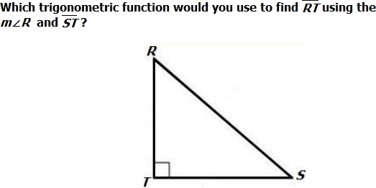

1. Sine
2. Cosine
3. Tangent
4. Secant

Alignment to SOL G.8.**2** (DOK 2)

1. 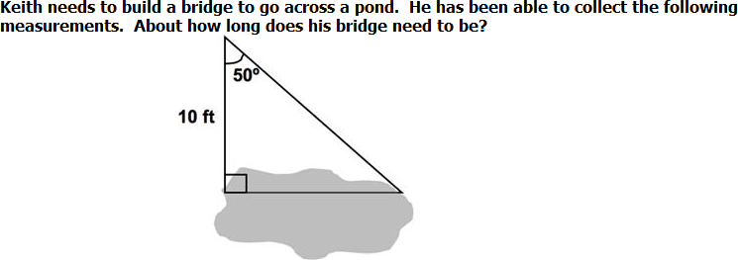Keith needs to build a bridge to go across a pond. He has been able to collect the following measurements. About how long does his bridge need to be?
2. 11.9 ft.
3. 7.7 ft.
4. 6.4 ft.
5. 8.4 ft.

Alignment to SOL G.8.**3** (DOK 2)

1. 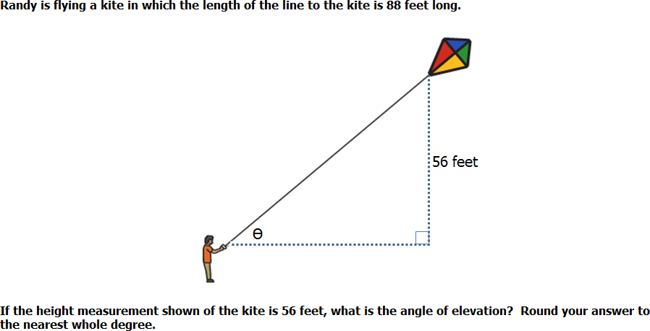Randy is flying a kite in which the length of the line to the kite is 88 feet long.

If the height measurement shown of the kite is 56 feet, what is the angle of elevation? Round you’re answer to the nearest whole degree.

Alignment to SOL G.8.**3** (DOK 3)

1. An 8-foot ramp needs to be elevated at an angle measuring 100 to be level with a step. Approximately how far does the ramp need to be away to hit the edge of the step?

Alignment to SOL G.8.**4** (DOK 3)

1. A person in a 300-foot-tall lighthouse is attempting to locate a boat floating in the water 720 feet from the bottom of the lighthouse. At what angle of depression should the light be shown to locate the boat?

**Every Student, Every Day, No Excuses**

***Student Personal Goals to Celebrate and Chart Progress***

|  |  |  |  |  |
| --- | --- | --- | --- | --- |
| **My Learning Goal** | **Getting Started** | **On my Way** | **I’m There** | **Notes to Self** |
| I can identify each trig ratio and determine when to use Sin, Cos, or Tan. |  |  |  |  |
| I can determine the properties of special right triangles. |  |  |  |  |
| I can solve problems, including practical problems, by using trigonometric ratios. |  |  |  |  |
| I can determine a missing angle or missing side of a trigonometric ratio problem involving two triangles. |  |  |  |  |

***What will we do for students who do not know it?***

***What will we do for students who already know it?***

Guided Group Lesson

Standard: Date:

|  |  |  |  |  |
| --- | --- | --- | --- | --- |
| Group Members | Emerging | Developing | Proficient | Distinguished |
|  |  |  |  |

Warm-Up:

|  |
| --- |
| Pairs of students are provided with a 4-column *Where Do I Belong* chart with columns labeled ‘Is a right triangle’’ ‘Is a triangle but not a right triangle’, ‘Not a triangle’, ‘How I know’. Students collaboratively sort cards of side length triples on the chart. |

Vocabulary

Triangle. Right Triangle. Hypotenuse Leg Right Angle

Ratio Trigonometry Sine Cosine Tangent

Opposite Adjacent

|  |  |  |  |
| --- | --- | --- | --- |
| Emerging | Developing | Proficient | Distinguished |
| Lesson focus:  Students play a game of What’s My Rule by creating their own game boards to find the length of missing sides in a variety of 30-60-90 and 45-45-90 triangles. Students challenge a partner, after verifying their board with the teacher. | Lesson focus:  Pairs of students are hired by NASA to determine the distance from their high school to a plane, meteor, asteroid, etc. using [NASA’s Space Math II Educator Guide](https://www.nasa.gov/stem-ed-resources/space-math-II.html). | Lesson focus:  Teams of students use *Trio of Thought* gameboard or *Quad for Thought* gameboard to read, analyze, solve, guide, and critique the reasoning of teammates in solving practical situations provided on task cards. | Lesson focus:  Students [investigate](https://www.stem.org.uk/resources/elibrary/resource/32181/trigonometry) an extension to Pythagoras’ theorem, use the sine and cosine ratios to solve problems, using the sine and cosine rules, explore the graphs of the sine function, use trigonometry in three dimensions, and find the angle between planes. |

|  |  |  |
| --- | --- | --- |
| Observations: |  | Next Steps: |
| What you notice about your students during small group instruction. | What will you do with these students next? Change groups, repeat, etc. |